Cressida Cowell

Cressida Cowell lives in London with her husband Simon, daughters Maisie and Clementine and son Alexander.

She was born on 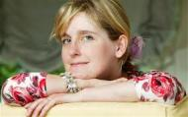15 April 1966 in London. As a child, she enjoyed drawing and writing 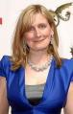stori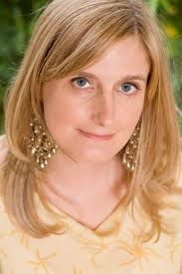es. She went to Oxford where she studied English and at St Martin's School of Art and Brighton University, she learned illustration.

“How to Train Your Dragon” was made into a film, which was released in 2010.

She was the Waterstones Children’s Laureate from 2019-2022. Cressida has also won the Nestle Children's Book Award and the Blue Peter Book Award.

