Sophie Kirtley

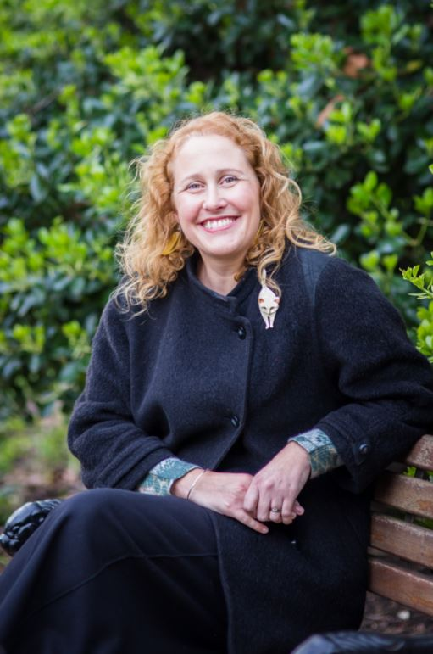

Sophie Kirtley grew up in Northern Ireland. She had a great childhood amongst hay bales, sand dunes and the waves of the Atlantic Ocean. She now lives in Wiltshire with her husband, children and a collection of pets and wild things.

Sophie taught English in high school for many years. She has also worked in a theatre, bookshop and a pub, where people tell fairy tales by candlelight.

Sophie believes stories are everywhere around us-through keyholes, in snippets of overheard conversation and in the forgotten finger of every lost glove. She feels so lucky to spend her time searching for stories and then writing them. Find out more at [www.sophiekirtley.com](http://www.sophiekirtley.com) and on Twitter @KirtleySophie