Hannah Gold

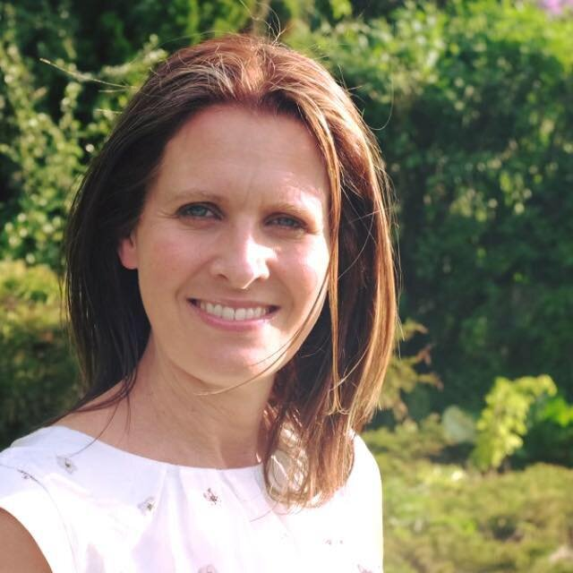

Hannah Gold grew up in a family where books, animals and the great outdoors were important. Hannah has always wanted to own a cat and be a writer. She has achieved both! Hannah studied screen-writing at university and went onto work in the London film and theatre industry. She now lives in Lincolnshire with her tortoise, her cat and her husband.

Hannah is passionate about writing stories which share her love of the planet and when not writing, she’s busy looking for her next big animal story and practising her roar.

Hannah’s first book, “The Last Bear”, won the Waterstones Children’s Book Prize and Blue Peter Book Award. It has been translated into 24 languages.

Find out more about Hannah at [www.hannahgold.world](http://www.hannahgold.world) and follow her on Twitter @HGold_author.