Facilities and Access

Facilities
- Disabled Parking
- Lift
- Toilets
- Changing Places Toilet
- Wheelchair Access & Facilities
- Baby Changing Facilities
- Induction loop at Reception area
- Gift Shop
- Free Wi-Fi
- Family Friendly Activities
- Pay & Display Parking (Limited Availability)

Parking
There are three designated disabled parking spaces in front of the Museum.  Lowered kerb (shown on the picture) is located right in front of the museum’s entrance. | 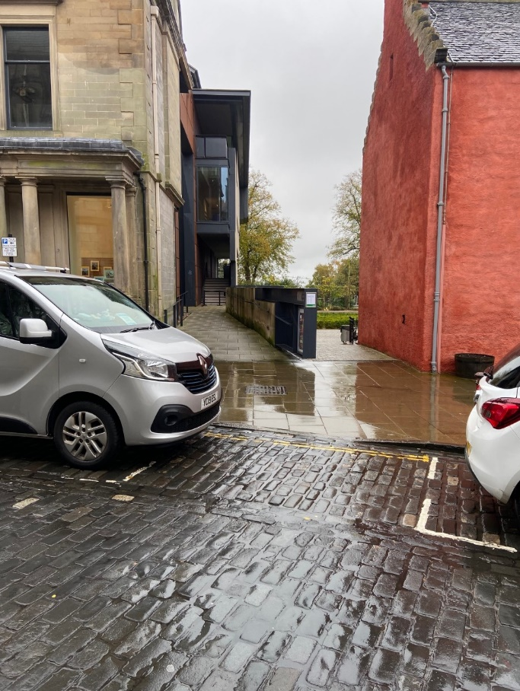
There are two additional designated disabled parking spaces behind the museum (Abbey Park Place, pictured). There is a slight uphill pavement leading to the museum’s main entrance. | 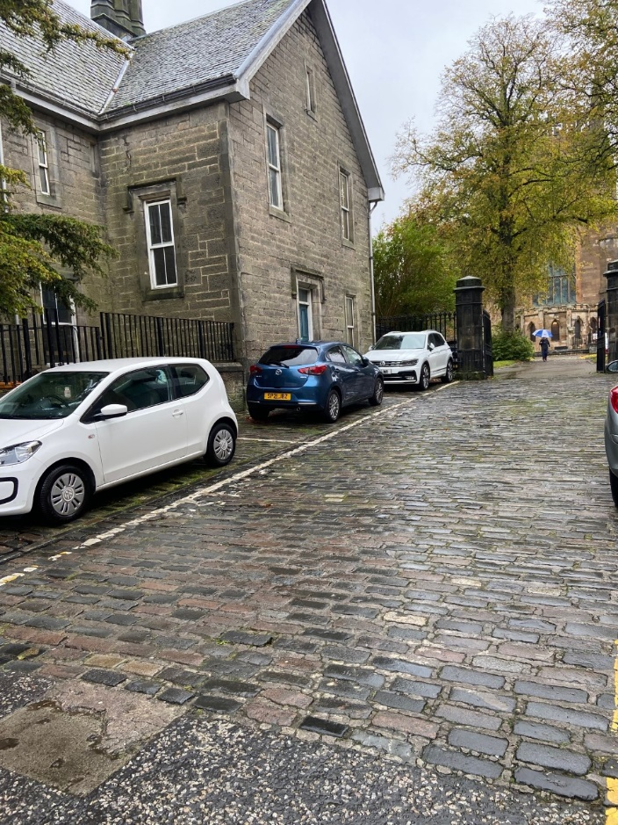

Access to the building
The main doors to the museum open automatically.  There is also a push button to the right of the door you can use when needed. (The button is circled in red in the photo) | 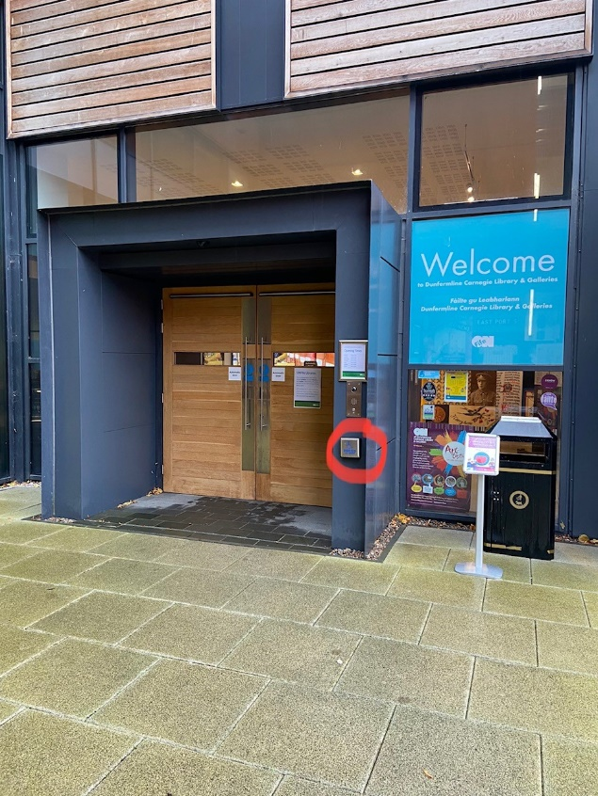

Access to Bruce Room

Bruce Room is located on the first floor.  There is both a staircase leading upstairs.  You can find the staircase by going through the archway and turning right.  For the lift access, turn left and head along the corridor to the reading room. | 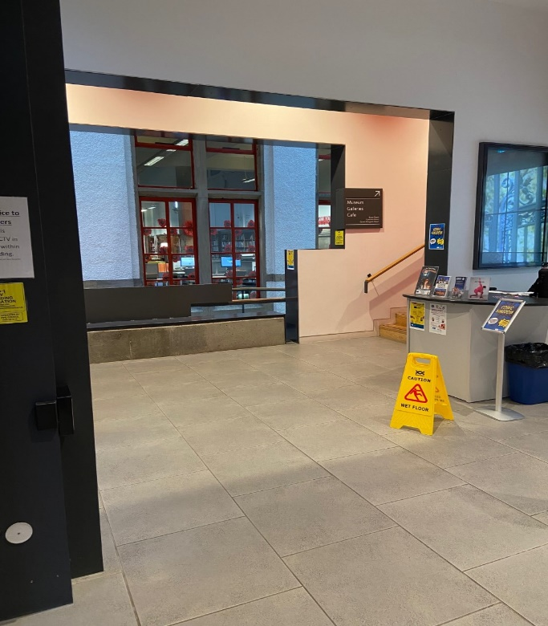
Route to the lift | 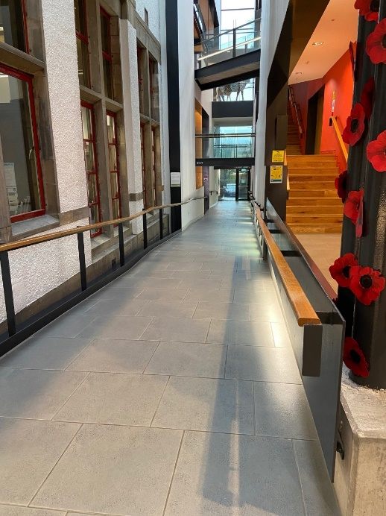
The lift is located next to the Reading Room.  The measurements of the lift are:  Door: 88cm wide  The lift space is: 158 cm long and 138 cm wide. | 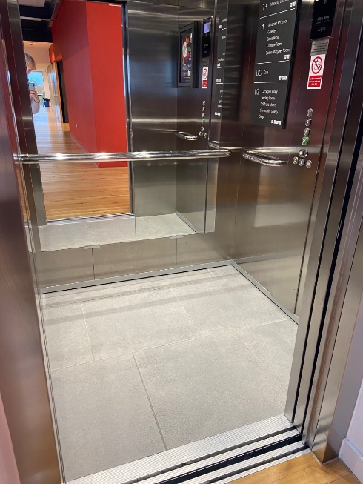

Bruce Room

The door to the room is 95 cm wide.

The Bruce Room has seating without armrests, and the tables are 74 cm high.

If you are not familiar with our building, you may wish to have a look at our virtual map.

Floor surfaces

The floor on the ground floor is tiled. The library is carpeted. | 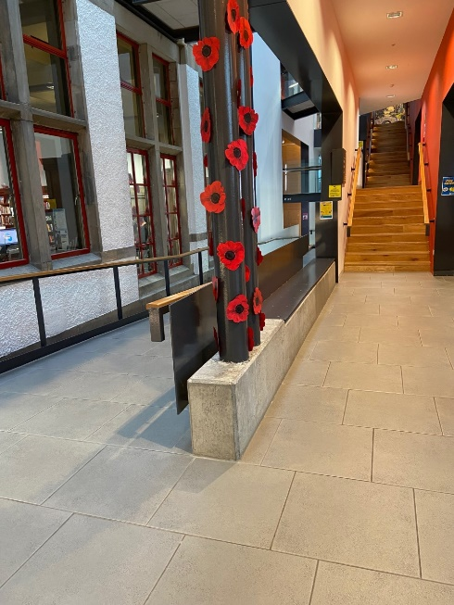
The floor on the first floor is wood and concrete.  Depicted here is the concrete path leading to Bruce Room. | 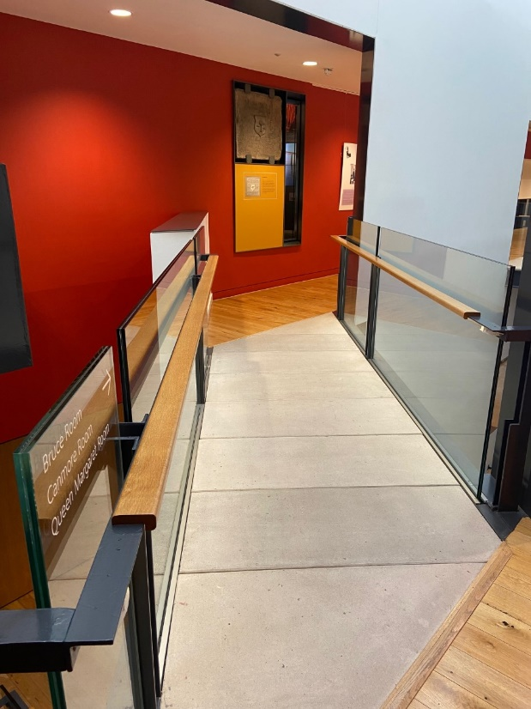
The floor in Bruce Room is carpeted. | 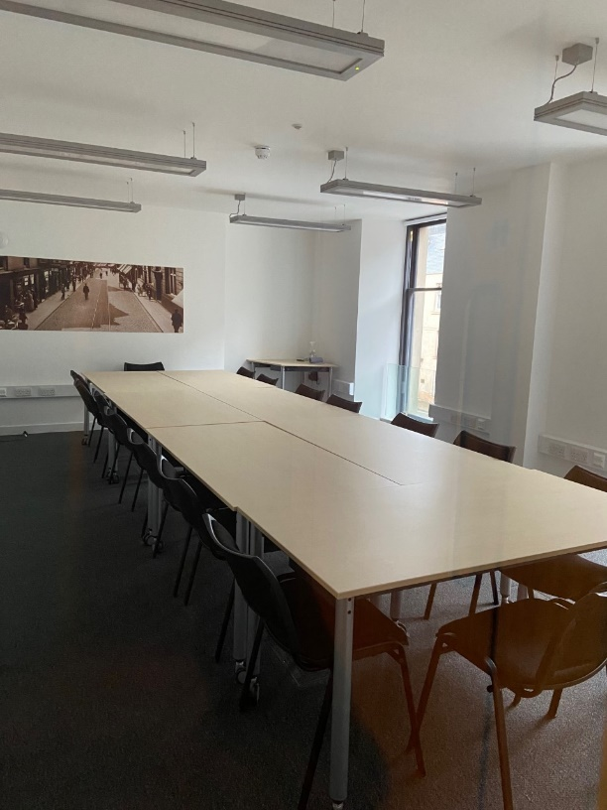

Toilet facilities

There is a gender neutral toilet next to Bruce Room. (The toilet cubicles are not visible on the photo. They are located on the right)
There is an electric hand drier, and also paper towels for drying your hands.

 | 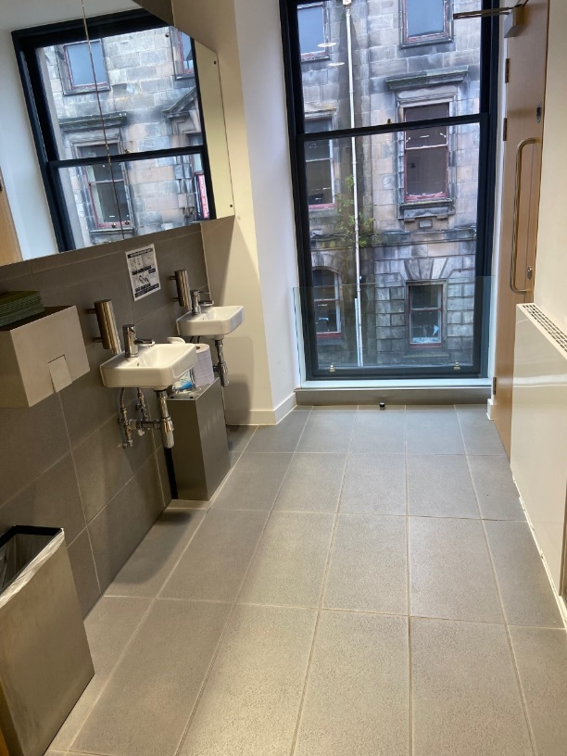
Wheelchair accessible toilet on the first floor is located next to the lift. The measurements of it are:  Door: 84 cm wide  Navigation space in the toilet is 120cm long and 120cm wide.  There are hand towels available. There is no electric hand drier. | 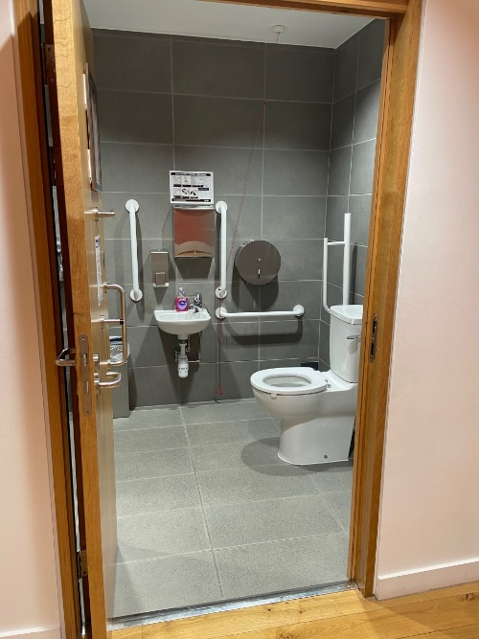
There is a Changing places toilet on the ground floor. Please ask staff if you wish to access it.  There are paper towels available and an electric hand drier for drying your hands. | 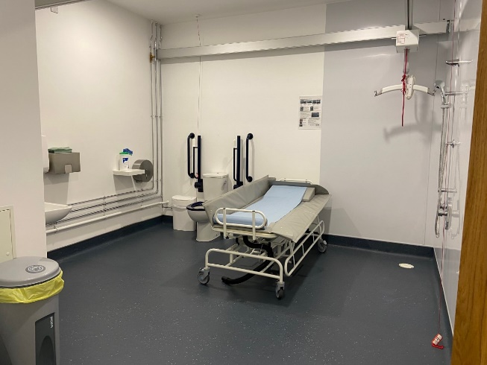
There is a non-automatic door leading from the Changing places toilet back to the museum.  Please ask staff if you need assistance. | 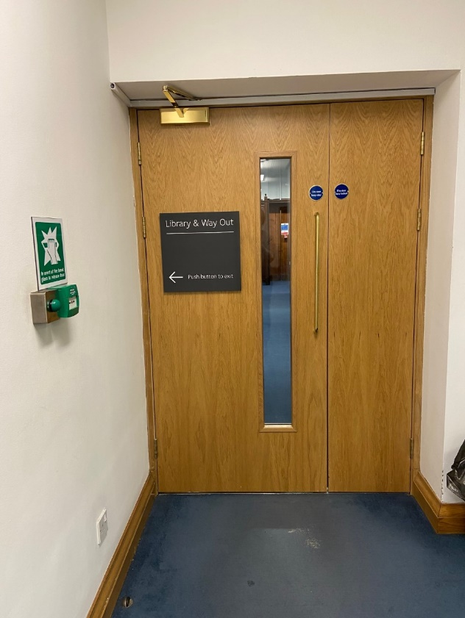

Additional support

The induction loop in the Bruce Room is currently not working. We apologise for the inconvenience.

There are wheelchairs available to borrow. Please ask staff.

If you wish to purchase your own radar key, they are available for £3.50 (relevant proof needed).

This session is run by
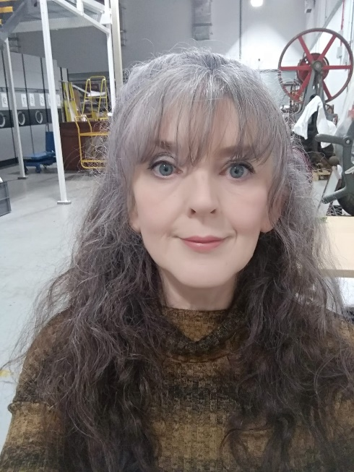 | 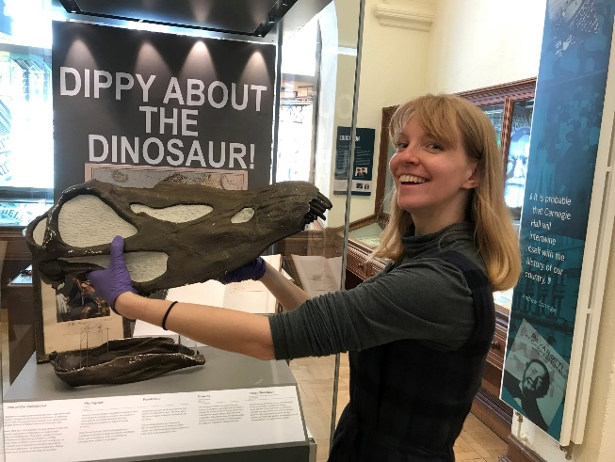
Lesley | Kirke

Additional info

We will be playing some quiet background music during the session. Please let us know if you prefer not to have any music in the room.
Please do not hesitate to contact us if you have any questions or concerns: kirke.kook@onfife.com or lesley.lettice@onfife.com

