Anne Miller

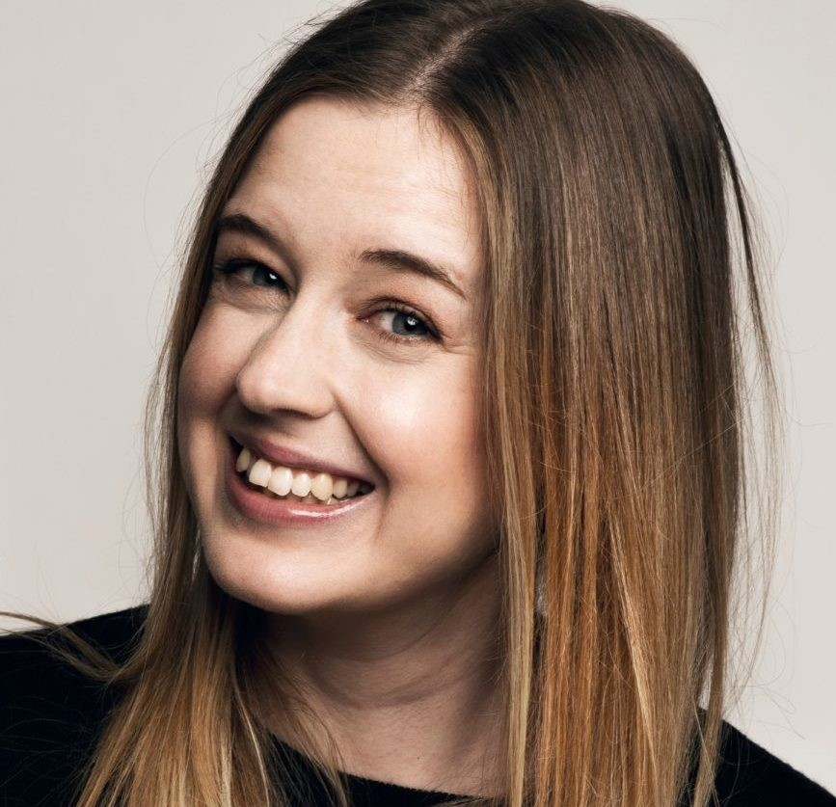

Anne Miller grew up in Newport and Tayport in Fife and went to school at Madras College in St. Andrews. At the very young age of 6, Anne wrote her first book, which her mum still has!

Anne now lives in London with her family, where she has some very interesting jobs! Anne works as a QI Elf, on the television programme QI and also works on the BBC Radio Four programme, The Museum of Curiosities

As well as working on TV, Radio and writing books, Anne reached the semi-finals of the BBC Two quiz, Only Connect. AND has not one, but TWO Blue Peter badges.

Mickey and the Animal Spies is Anne’s debut novel, with Mickey and the Trouble with Moles and Mickey and the Missing Spy also in the popular series.