**Helen Peters**

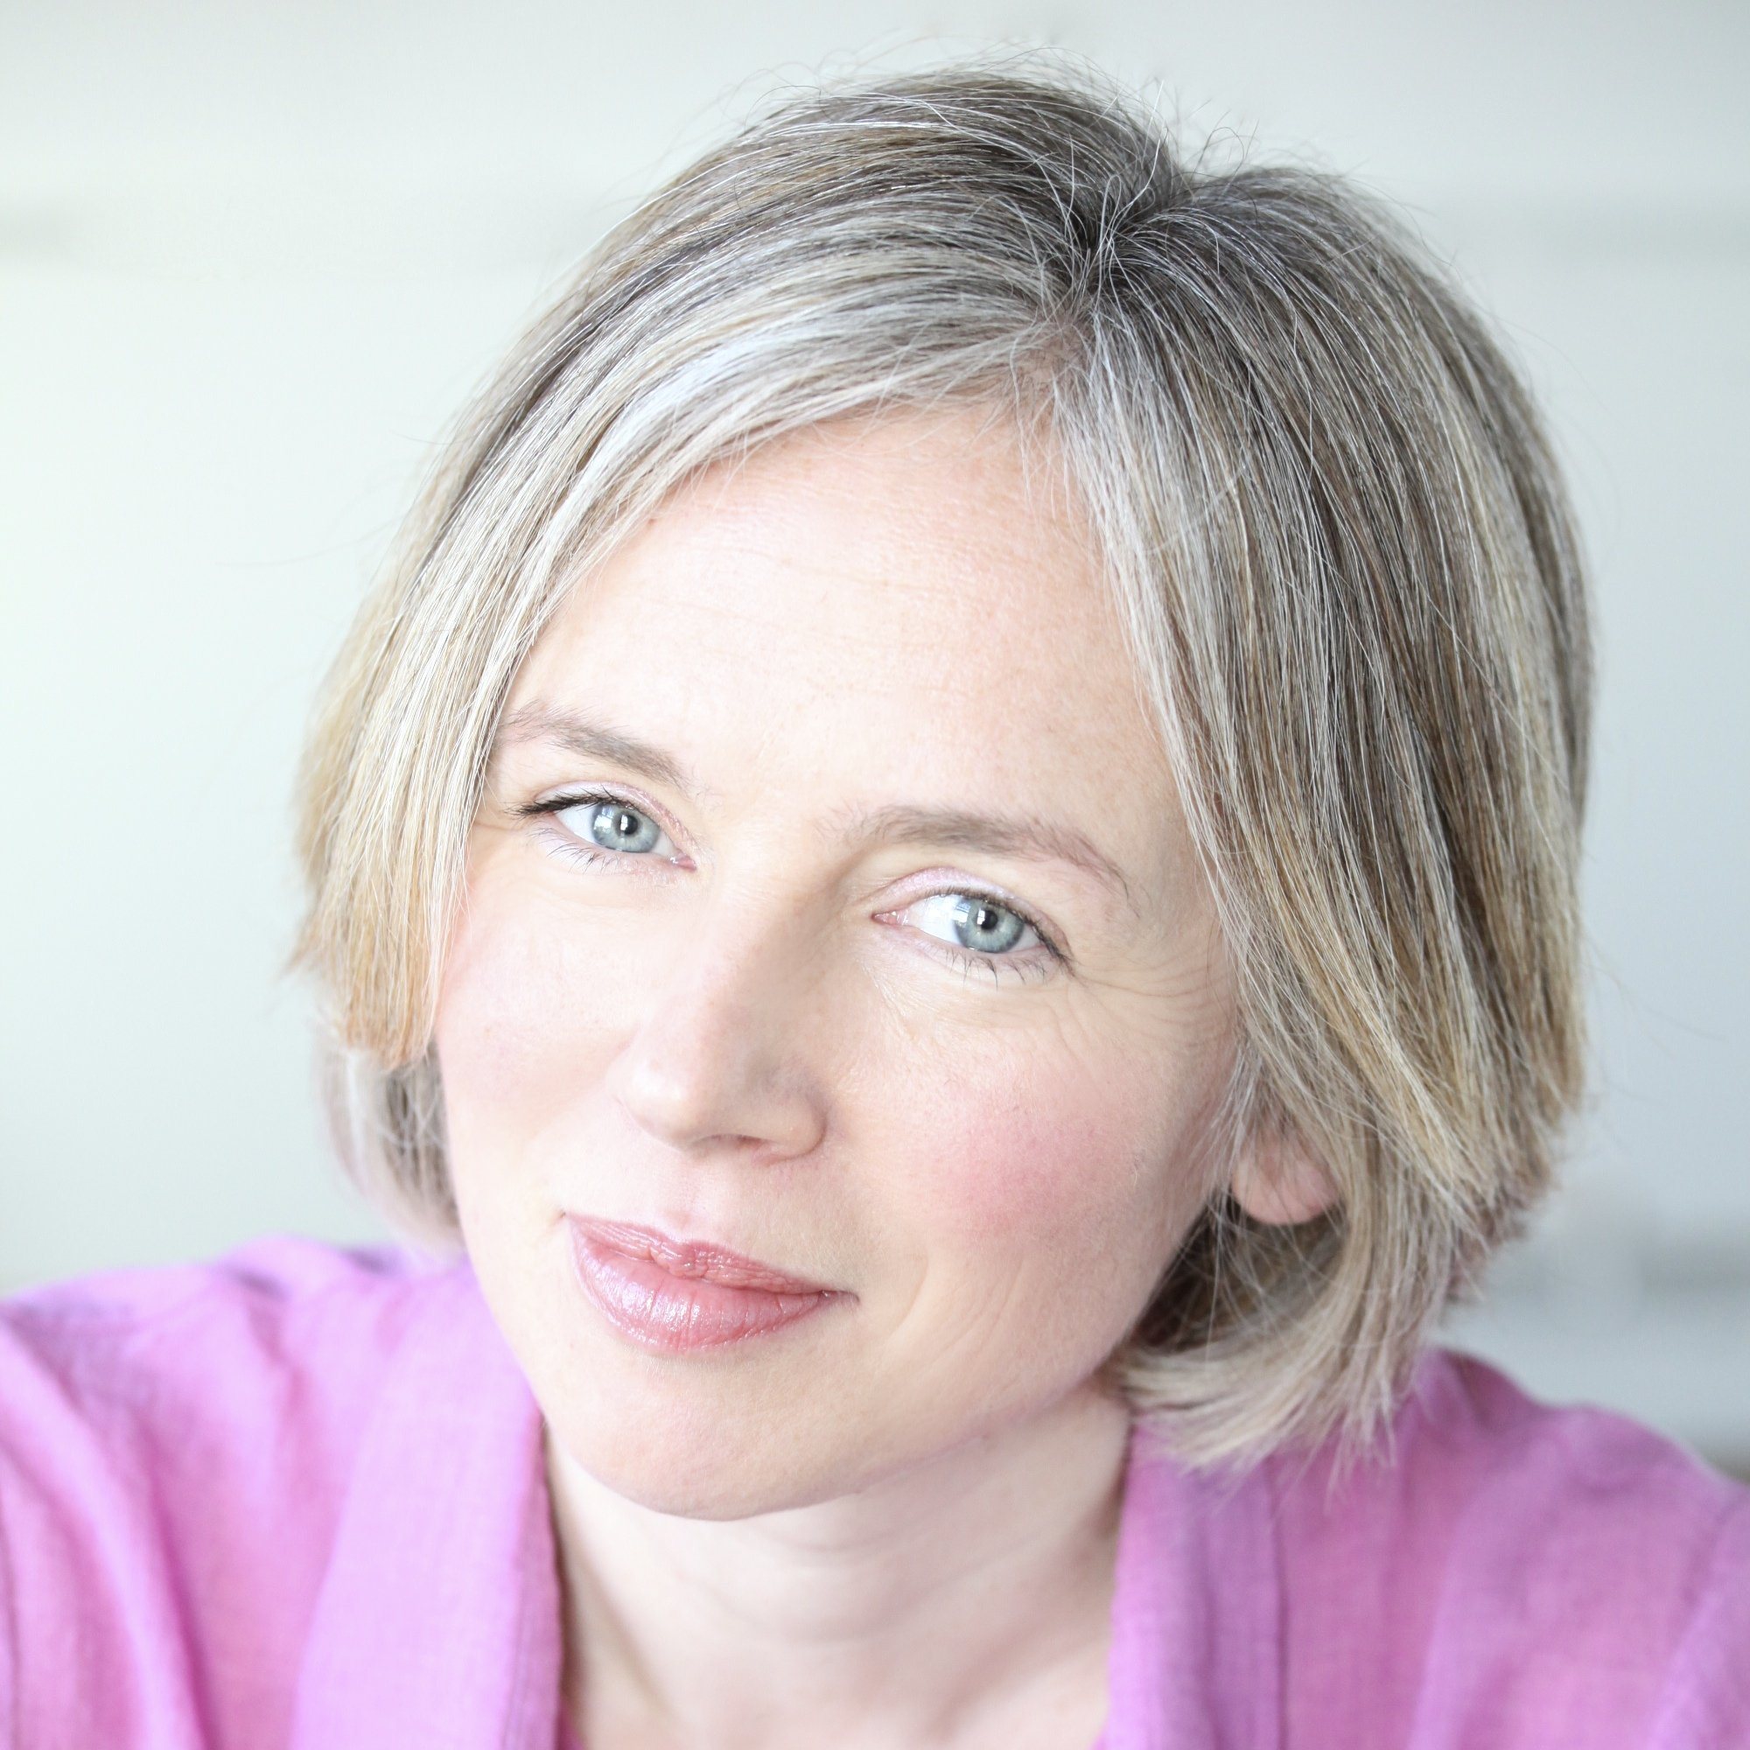

Helen Peters grew up on an old-fashioned farm in Sussex, surrounded by family, animals and mud. She spent most of her childhood reading stories and putting on plays in a tumbledown shed that she and her friends turned into a theatre. After university, she became an English and Drama teacher in a large comprehensive school in London. She spent her summer holidays travelling all over the world. Helen now lives in East Sussex with her two children, two cats, two guinea pigs and her husband.

Find out more on Helen’s website

<https://www.helenpetersbooks.com/>