**Onjali Q. Rauf**

[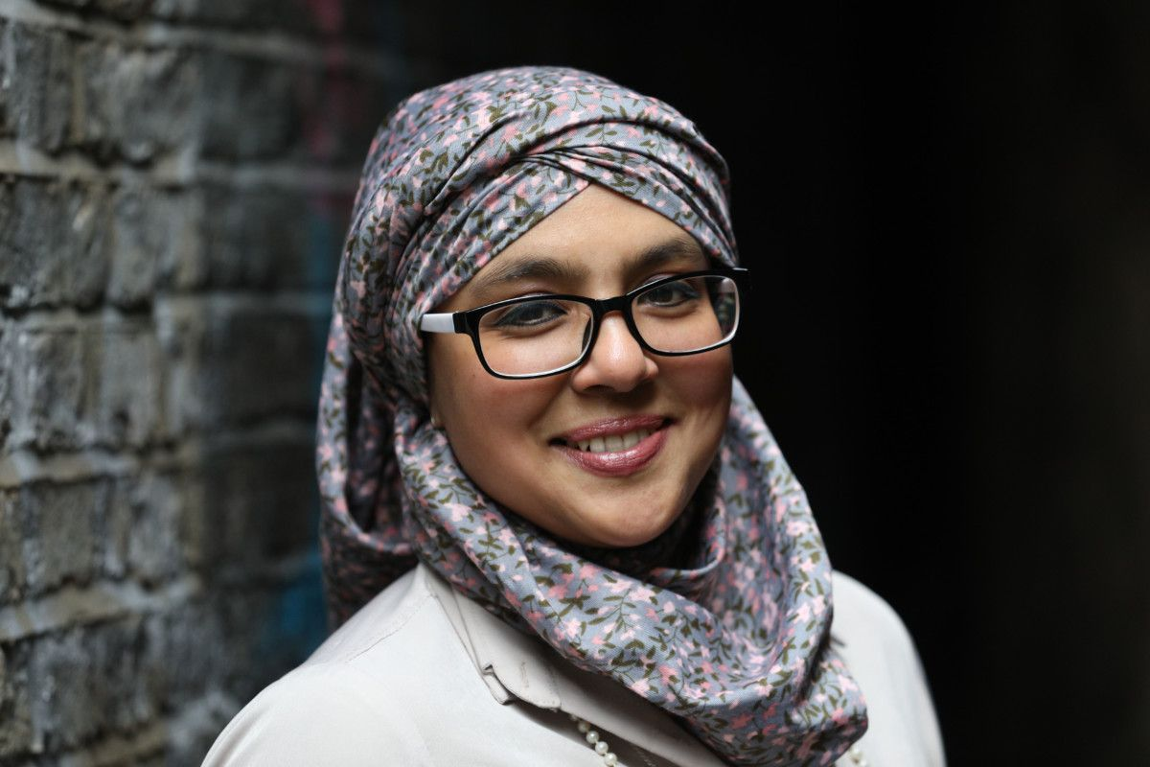](https://www.google.co.uk/url?sa=i&rct=j&q=&esrc=s&source=images&cd=&ved=&url=https://inews.co.uk/culture/arts/syrian-child-refugee-story-wins-waterstones-childrens-book-prize-2019/&psig=AOvVaw1I8sZXuJnXuIxWkFgsSz-j&ust=1557845717216380)

**Onjali Q. Rauf specialised in Women’s Studies at the University of Wales, Aberystwyth and Oxford University. She is the founder and CEO of Making Herstory**, which works to end abuse and trafficking of women and girls.

Onjali had been travelling to the refugee camps of Calais and Dunkirk for the past 3 years trying to help the women and children stuck there with emergency aid. After she had to undergo life-threatening surgery herself, she thought even more about what these women and children were suffering without medical intervention. She had never thought about writing a book before to highlight the issues surrounding immigrants, but then the idea came to her.

To relax, Onjali likes to switch off her phone, head to a café with a good book, go travelling to new places, eat good food (especially something with chocolate in it) and watch something funny to end the day.