**Andrew Cope**

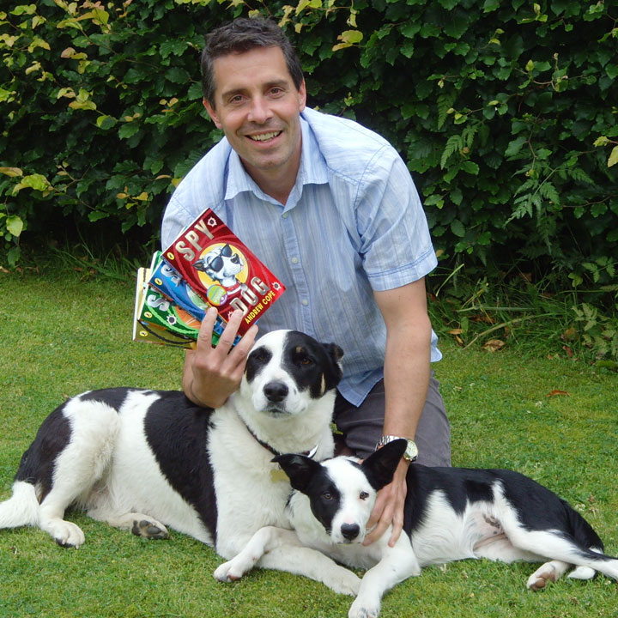

Andrew Cope was born in Derby in 1966. He is a teacher, writer, a huge fan of Derby County football club and author of the Spy Dog series.

He really does have a dog called Lara who has one sticky-up ear and came from the RSPCA, but he's not sure if she is actually a highly trained secret agent. Andrew lives with his wife and two children.

To find out more about Andrew, the Spy Dog and Spy Pups series visit <https://www.spydog451.co.uk/>