**Sarah Lean**

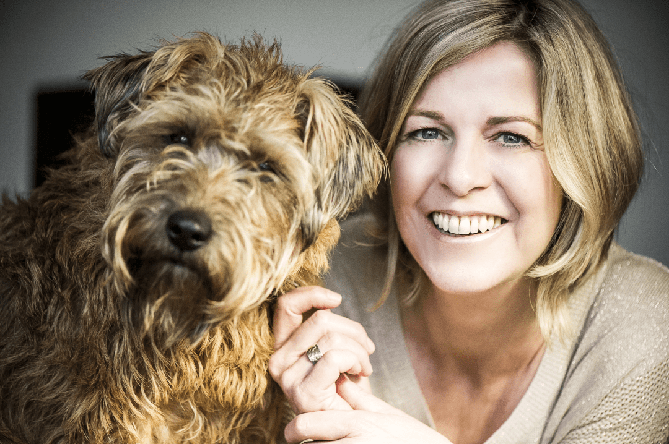

Sarah was fascinated by animals and becoming a writer from a very young age. She even dictated her stories to her mum, who then typed them up for her.

Sarah has many hobbies including, gardening, art, calligraphy and being outdoors. She lives in Dorset with her two dogs, Harry and Coco.

“A Dog Called Homeless” was Sarah’s first published book in 2012.

If you’d like to find out more about Sarah, her books, and work then visit https://sarahlean.co.uk/