Gwyneth Rees

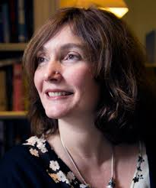

**Gwyneth Rees was born on 10th May 1968.** She is half Welsh and half English and moved to Scotland when she was six. She wrote her first book in a jotter when she was ten, inspired by Enid Blyton. She studied medicine at Glasgow University and then specialised in child and adolescent psychiatry before she became a full-time writer in 2003. Her books have won and been short-listed for various awards.

Gwyneth now lives near London with her husband, two daughters and one noisy cat.

You can follow her on Twitter @gwyneth_rees