**Geraldine McCaughrean**

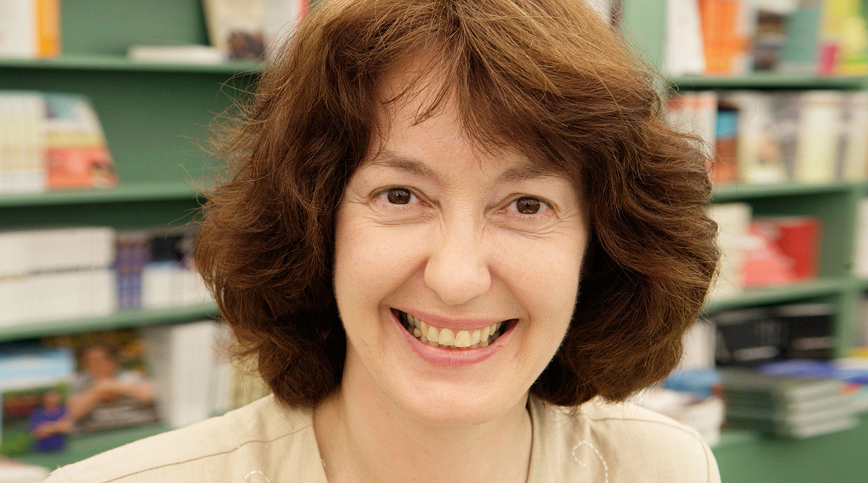

Geraldine’s older brother became a published author at the age of 14, which spurred Geraldine on to have the ambition of becoming a writer too.

She has now written more than one hundred and seventy books for adults and children, and has won the prestigious Carnegie Medal, not once but twice. Geraldine also wrote the official sequel to J.M. Barrie’s Peter Pan.

If you’d like to find out more about Geraldine, her books, and work then visit <https://www.geraldinemccaughrean.co.uk>