**Christopher Edge**

Christopher grew up in Manchester where he spent a lot of time in the local library, dreaming up stories. He went on to study English at university and then worked in a record shop, before becoming an English teacher for a short time. He followed that by working in publishing, which allowed him to read lots of children’s books, and in 2007, he went freelance as a publishing and education consultant.

His novels have won several children’s book awards and have also been nominated for the CILIP Carnegie Medal.

Christopher now lives in Gloucestershire with his wife and two children and he still spends most of his time in the local library, dreaming up stories.

[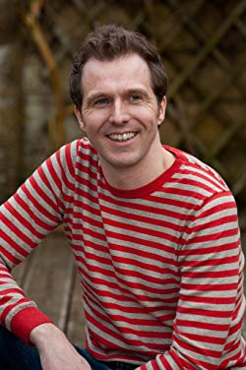](https://www.google.co.uk/url?sa=i&rct=j&q=&esrc=s&source=images&cd=&cad=rja&uact=8&ved=2ahUKEwjz2cb3047hAhVJLBoKHaRoDdoQjRx6BAgBEAU&url=https://www.amazon.co.uk/Christopher-Edge/e/B00LXTRLS6&psig=AOvVaw0-RpQ_NJHcOMca8j9JHtGV&ust=1553100378914158)