**Catherine Bruton**

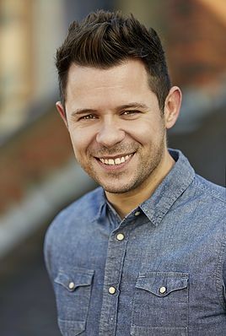

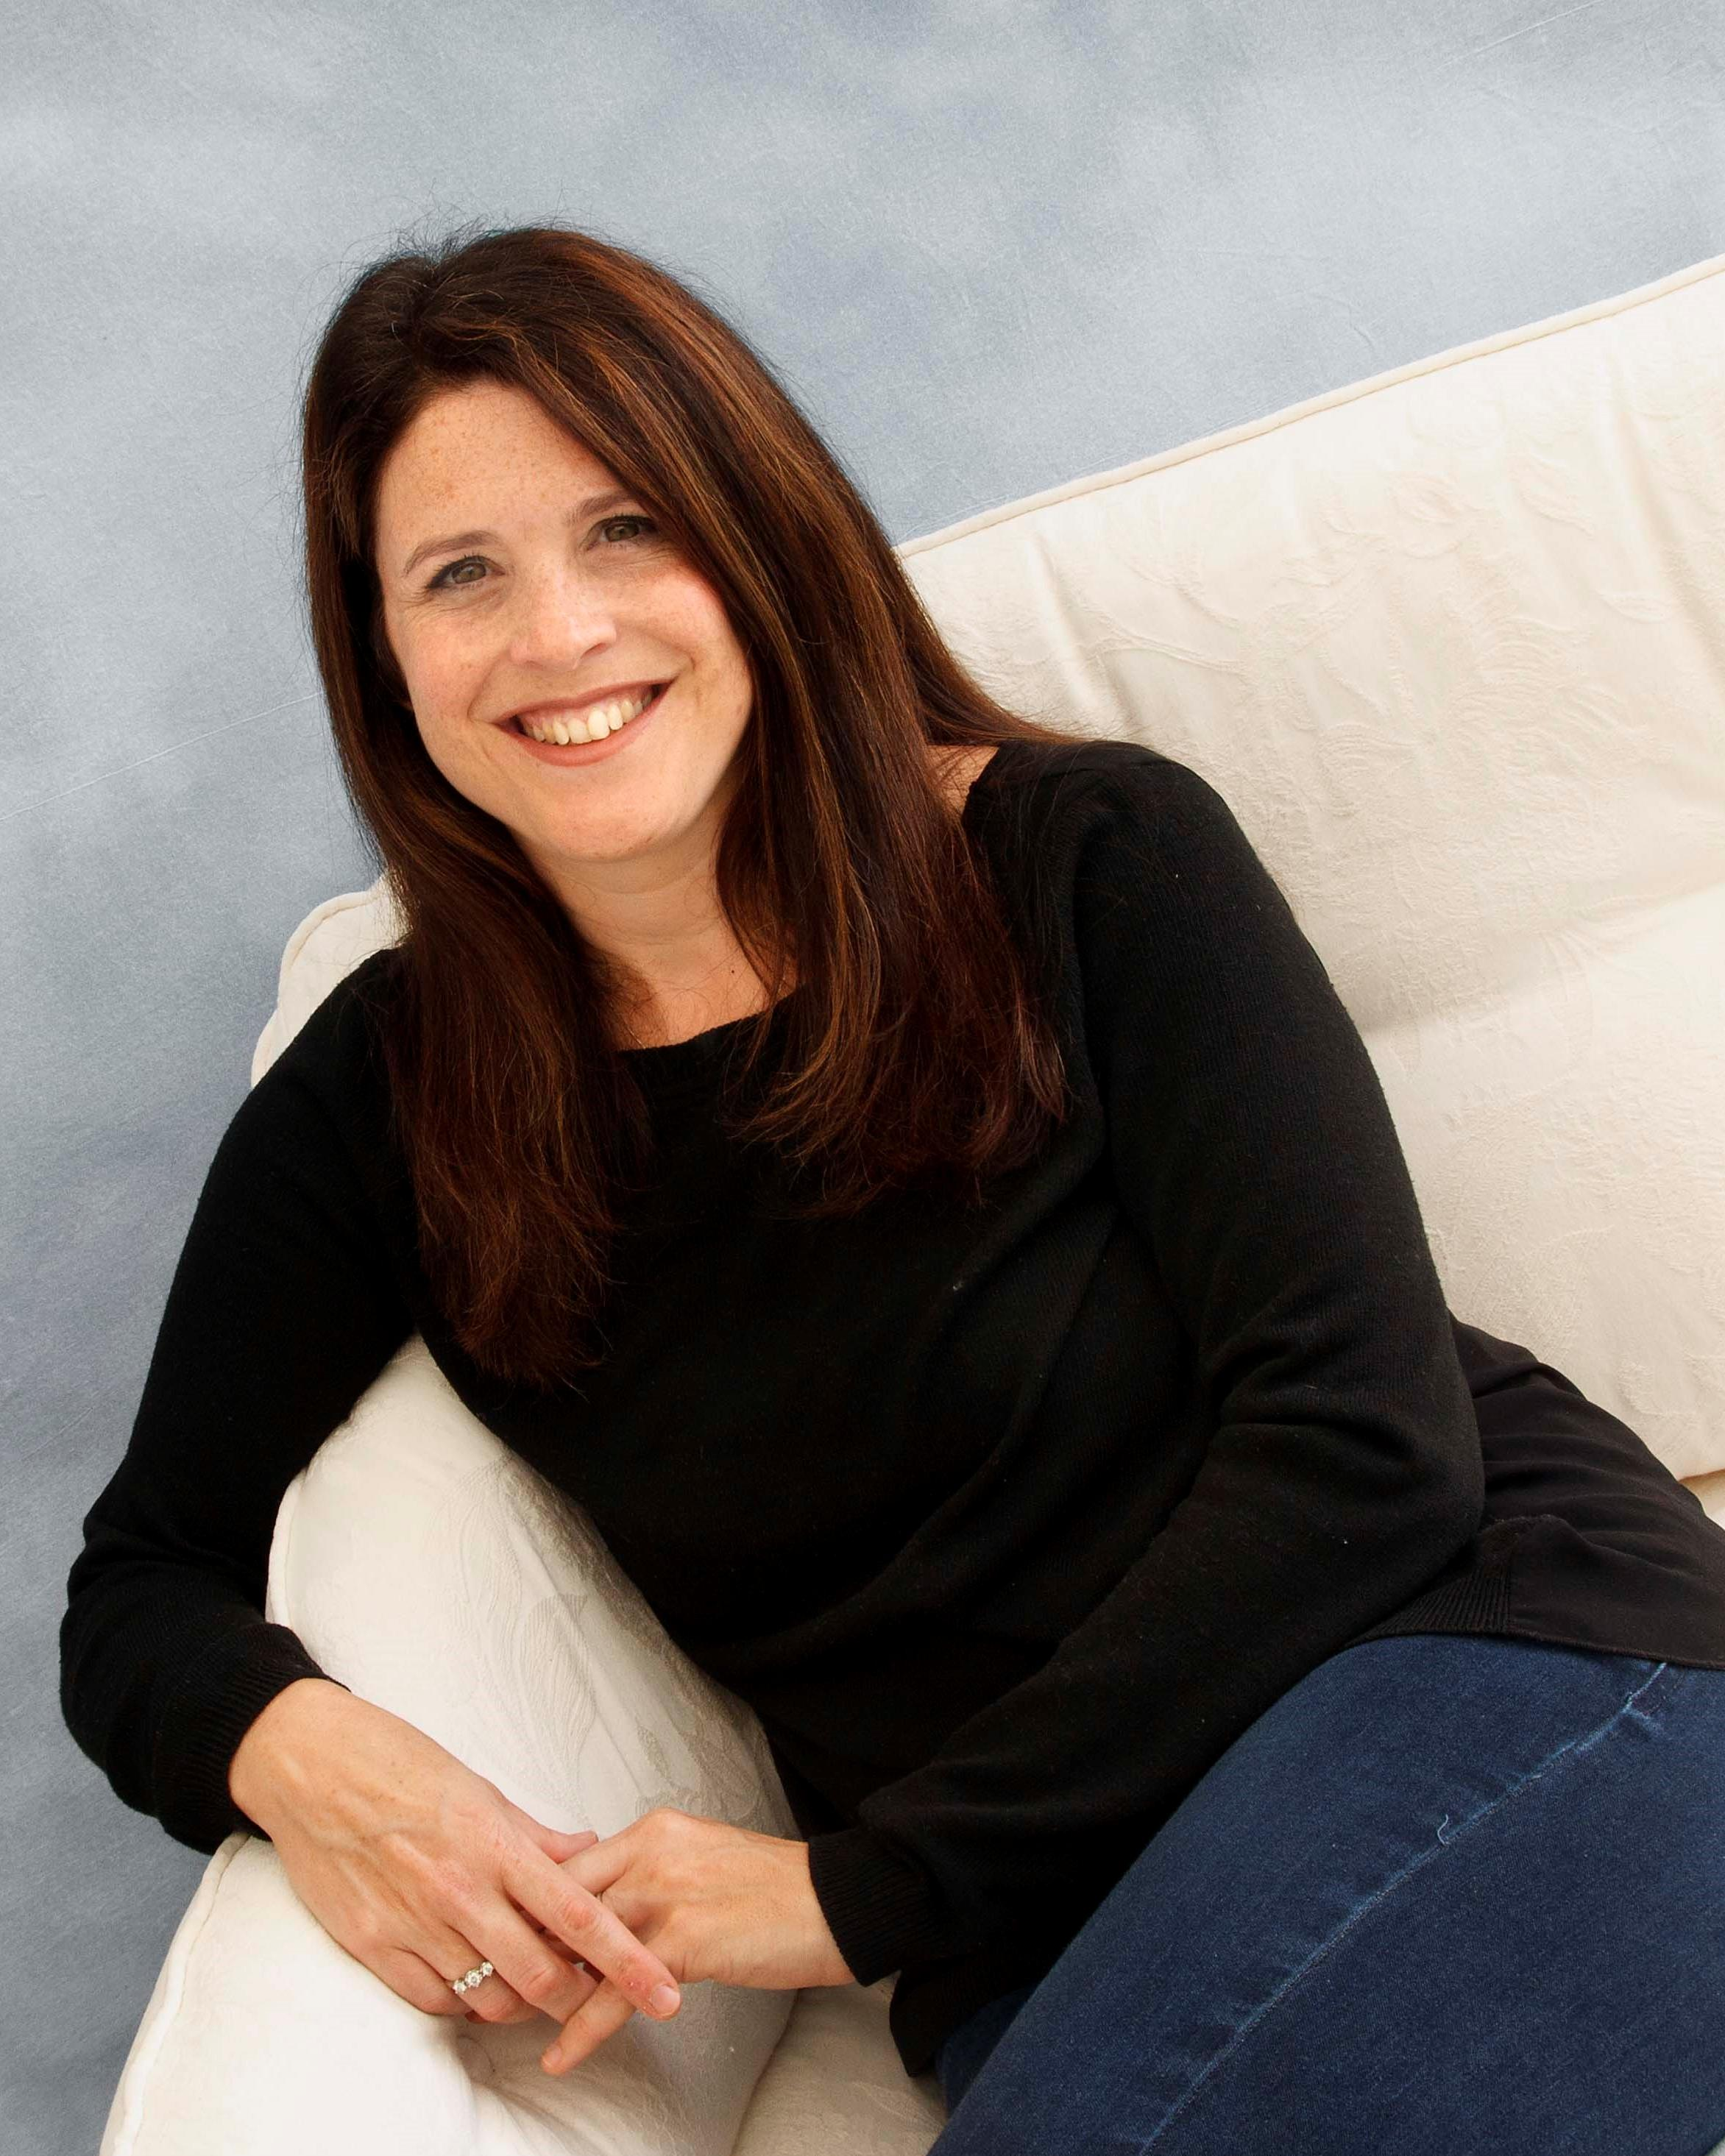

Catherine Bruton studied English at Oxford University. She now lives just outside Bath with her husband and two children. She teaches English and Drama three days a week alongside being an award-winning author.

She started writing when she was teaching in Africa in her gap year. She was in the middle of nowhere with no electricity, no TV, no radio, no newspapers, no telephone, no internet and very few books, so she started writing stories about the children in the school and all the strange things that went on and has been writing ever since.

You can follow Catherine on Twitter @catherinebruton

