**Betty G. Birney**

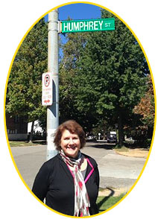

Betty G. Birney wrote her first book at the age of 7 as a schoolgirl in Missouri, America. Betty has had many jobs and has even worked for the Disney Channel as a writer and story editor.

Betty has won many awards for her work and says that writing books is her first love and has written more than 35 children’s books to prove it, many of which have a Disney theme.

If you’d like to find out more about Betty, her books, and work then visit <https://www.bettybirney.com/>