**Angie Sage**

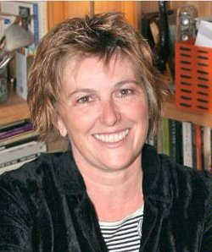

Angie Sage was born in London and grew up in the Thames Valley, London, and Kent. She now lives in Somerset in a very old house that has a secret tunnel below it. Angie is the author of the Septimus Heap series as well as the Araminta Spook books.

Angie Sage's own house is home to three [ghosts](http://www.kidzworld.com/article/913-scary-places-1-tower-of-london) - but they are quite shy! Angie Sage made a living as an illustrator before she made the move into writing.

Angie Sage owns a boat named Muriel, just like the one in the Septimus Heap books. Angie Sage has two daughters. Her favourite book to read to them when they were kids was “Where the Wild Things Are” by Maurice Sendak. Angie Sage's [favourite colour](http://www.kidzworld.com/quiz/3306-quiz-the-power-of-color) is blue.