**Cath Howe**

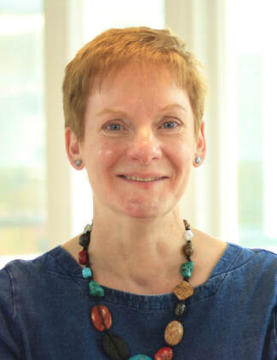

Cath Howe lives in South West London and is an author and teacher.

“Ella on the Outside” was Cath’s debut novel and won the North Somerset “Moving On” award in 2019.

Cath has also written ***How to be Me*** and ***Not My Fault***.

If you’d like to find out more about Cath and her books, then visit <http://www.cathhowe.com/>.