**Marcia Williams**

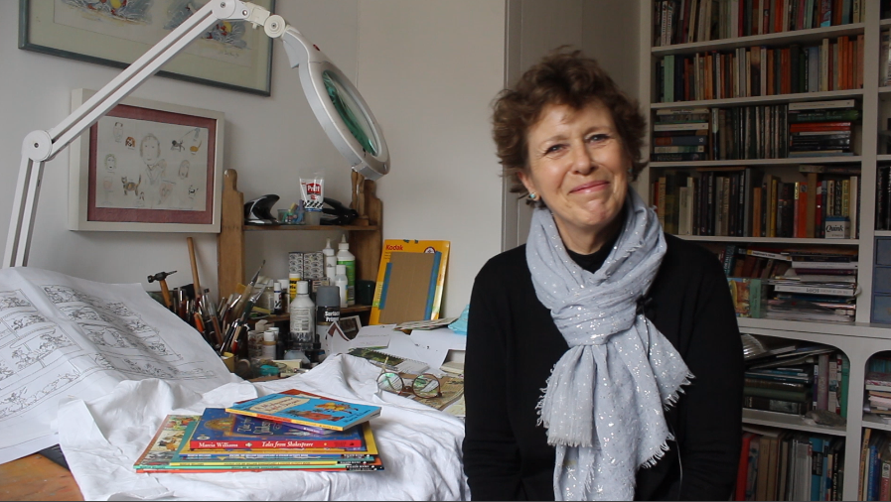

Marcia Williams loved books from an early age and remembers being read to almost every night. Sometimes she would be scared, especially by fairy tales, but still didn’t want them to end!

Her mother was a writer and her father was a playwright and theatre director. She went to boarding school in Sussex, from where she sent weekly illustrated letters to her parents overseas.

Marcia calls herself "an obsessive illustrator”. She had a number of jobs, including being a nursery teacher, which is when she developed her taste for storytelling to young children. When she gave up teaching to paint, she studied watercolour at Richmond College and held some successful local exhibitions, before a friend suggested that she took her work to show to Walker Books.

Marcia lives in London and has two grown-up children, three grandchildren, one extra-large dog and a cat.