**Elizabeth Laird**

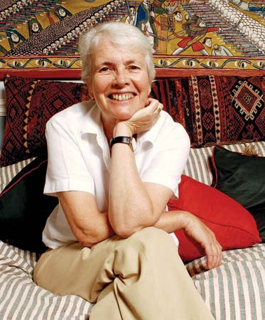

Elizabeth was born in New Zealand in 1943. Both of her parents were Scottish. Her dad was a ship’s surgeon. Elizabeth had always wanted to travel, so when she was 18, she went to Malaysia to teach at a local school. When she got married, she moved to Iraq where her husband worked. After their son was born, they moved to Beirut but as the civil war was raging, they were evacuated to Vienna, where she then had their second son. After all these adventures, they eventually settled in London for a while and both she and her husband became writers. Elizabeth has travelled far and wide and these travels have influenced her writing. Her favourite place in the world is Ethiopia, where she lived and worked for several years before the civil war. Elizabeth now lives in Edinburgh and doesn’t travel as much these days, but if she got the right invitation, she would be off!