**Ross MacKenzie**

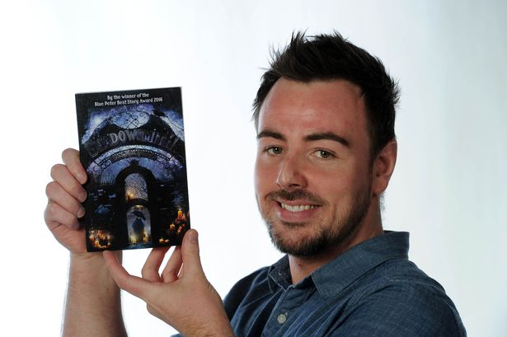

Ross MacKenzie is a multi- award-winning author. His books include *The Nowhere Emporium trilogy,* *Shadowsmith* and *Evernight.*

His highly-acclaimed fantasy novel, *The Nowhere* *Emporium,* won numerous accolades including the Blue Peter Book Award and the Scottish Children's Book Award.

Ross lives in Renfrew, Scotland, with his wife and two daughters, but spends much of his time in another world.

Ross is on Twitter at @RossAuthor