**Piers Torday**

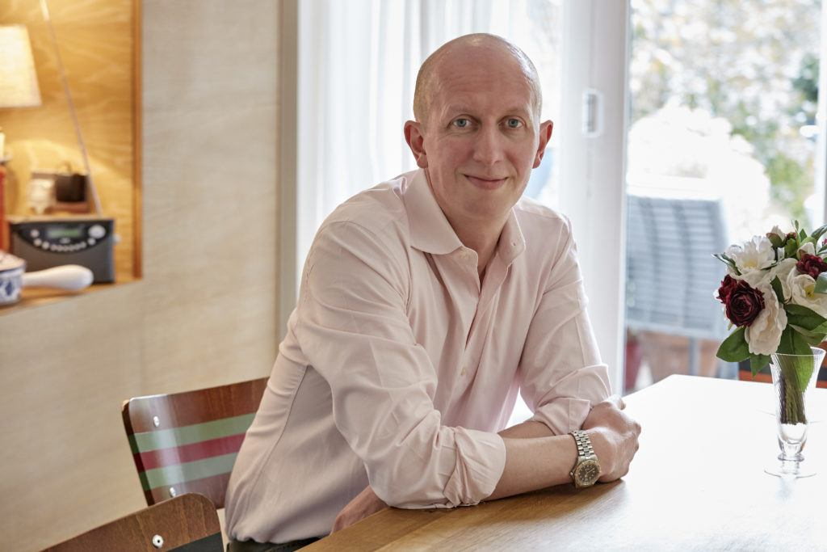

Piers Torday grew up in England and has been surrounded by books all his life, as his mother owned a children’s bookshop. His parents and grandfather all wrote too, so writing and storytelling really does run in his family.

Piers had worked in theatre and TV before going on a writing course in 2008. In 2013, *The Last Wild* was published, followed by the sequels *The Dark Wild* in 2014 and *The Wild Beyond* in 2015, which completed the trilogy.

Piers is an award-winning author, who continues to write for children, adults and TV and has come a long way since he wrote his first award winning cartoon at the age of 7.

If you’d like to find out more about Piers, get writing tips and listen to some online readings then visit <https://www.pierstorday.co.uk/>