**Hilary McKay**

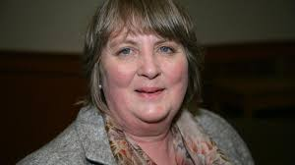

Hilary was born in Boston, Lincolnshire, and is the eldest of four girls. She studied botany and zoology at St. Andrews University and went on to work as a biochemist before becoming a full-time writer.

Hilary has won many awards for her books, including the Guardian Children’s Fiction Prize for her first novel, *The Exiles* and Costa Children’s Book Awards for *The Skylarks’ War.*

Hilary now lives in Derbyshire with her family.

To find out more about Hilary and the many books she has written visit <https://www.hilarymckay.co.uk/>