**Em Lynas**

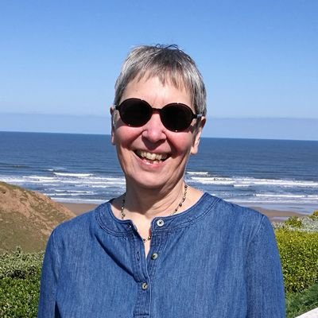

Em Lynas is a children’s author and she just loves silly poetry, magic, dragons and folklore. Em gets her ideas for her books while she is on the beach or in the bath.

Before becoming a published writer, Em had many jobs, which included working as a shelf stacker, a shoe shop assistant, a primary school teacher, a mum AND an educational publisher.

Em lives by the seaside on the North East Coast of England with her husband.

If you’d like to find out more about Em and her books, then visit <https://www.emlynas.com/> where you can also find teaching resources and generate your witch name. You can also find Em on Twitter at @emlynas