**Pamela Butchart**

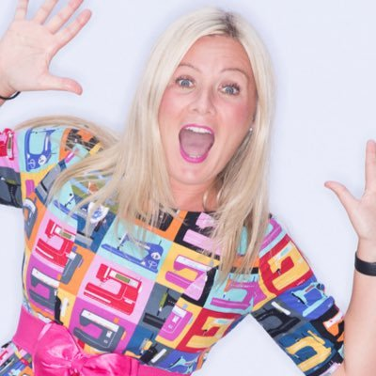

Pamela Butchart has won many awards for her writing, including the Blue Peter Best Story Award and The Children’s Book Award.

As well as being a writer, Pamela also teaches Philosophy at a Secondary School. Many of her books are based on her own childhood, where many weird and spooky things happened at the schools she attended …. (well, Pamela says in her imagination they did!).

Pamela lives in Dundee, with her son and two cats.

Pamela also writes picture books, loves cats, kinder eggs, funny babies, cheese and dinosaurs!

Pamela can be found on Twitter at @Pamela_Butchart