**Maz Evans**

[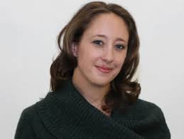](http://www.google.co.uk/url?sa=i&rct=j&q=&esrc=s&source=images&cd=&cad=rja&uact=8&ved=2ahUKEwjYoLS73czgAhUFHxoKHVSaBacQjRx6BAgBEAU&url=http://www.scottishbooktrust.com/blog/teachers-librarians/2017/10/maz-evans-why-we-must-care-for-our-young-carers&psig=AOvVaw0rEeglbBhE0_Q0INOlu1Fv&ust=1550835189020831)

Maz (Mary Alice) Evans began her writing career in journalism as a TV critic and feature writer for many newspapers and magazines. She still regularly broadcasts on radio, on such shows as The Jeremy Vine Show.

“Who Let the Gods Out”, her first novel, entered the bestseller charts in its first week of publication and has been sold in 17 countries. It was also shortlisted for many awards, including the Carnegie Medal.

After working as a creative writing lecturer, she founded Story Stew, a creative writing programme that has visited primary schools and literary festivals around the UK, including Hay and Imagine.

Maz lives in Dorset with her husband and four children. Find out more about that author at <https://maz.world/>