**Jo Simmons**

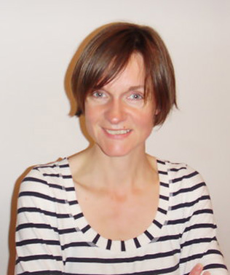

Jo Simmons began her working life as a journalist. Her first fiction series for children, *Pip Street*, was inspired by her own kids' love of funny fiction, and two *Super Loud Sam* books followed. *My Parents Cancelled My Birthday* is Jo's third book for Bloomsbury.

In addition to children's fiction, she has also co-written a humorous parenting book, *Can I Give Them Back Now? -The Aargh to Zzzz of Parenting*.

Jo lives in Brighton with her husband, two boys and a scruffy, formerly, Romanian street dog.