**Clive King**

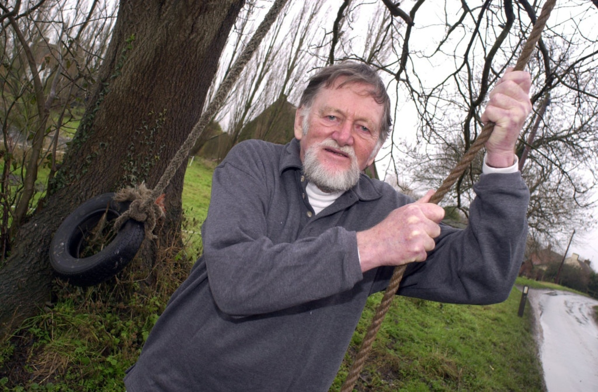

Clive King was born on 28th April 1924 in Richmond, Surrey. With his family, he moved to Ash, a village near Sevenoaks in Kent, which he used as the setting for “Stig of the Dump”. He joined the Royal Navy Volunteer Reserve in 1943 and served in World War 2, after studying at Downing College, Cambridge. In 1948, he joined the British Council and was posted overseas to a variety of countries.

“Stig of the Dump” was Clive’s third and most famous book. In 1973, he became a full-time writer. Clive’s favourite place in the world was at sea. He tried to learn ten languages. His hobbies were carpentry and cooking. He died in 2018, aged 94.