**Malorie Blackman**

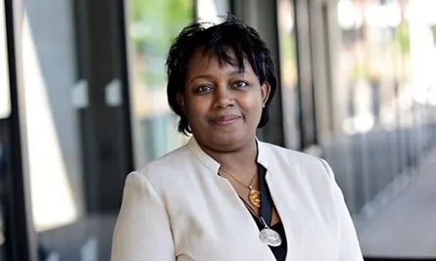

Malorie Blackman was born on 8th February 1962 in Clapham. Her parents were both from Barbados. When at school Malorie wanted to be an English teacher but ended up working as a systems programmer. Malorie was awarded an OBE in 2008 and held the position of Children's Laureate from 2013 to 2015.

Malorie primarily writes literature and television drama for children and young adults and has used science fiction to explore social and ethical issues.

Her books have been shortlisted and won many awards over the years.