**Katie & Kevin Tsang**

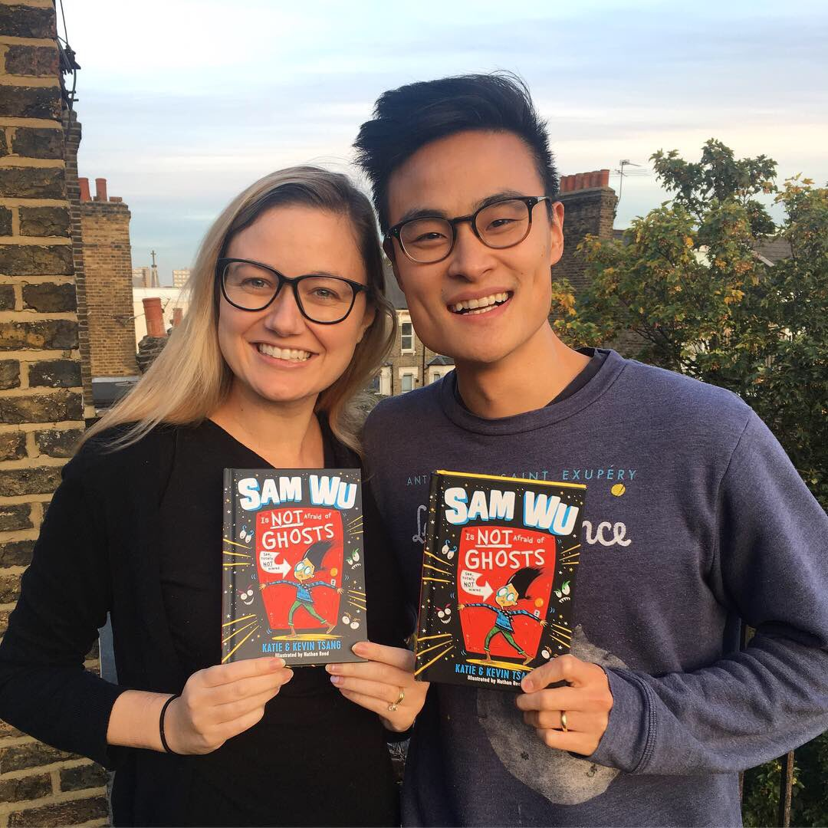

Katie and Kevin Tsang met while studying in Hong Kong, are now married and have a young daughter. They’ve travelled the world and have lived on three different continents but are now settled in London.

Katie also writes for Young Adults as Katherine Webber and is originally from California. Kevin was born in Copenhagen, Denmark but grew up in Atlanta, Georgia.

They have written two book series together, Sam Wu and the Dragon Realm series.

Find out more about the authors at <https://katieandkevintsang.com/> or follow them on Twitter @kwebberwrites & @kevtsang