**Jessica Townsend**

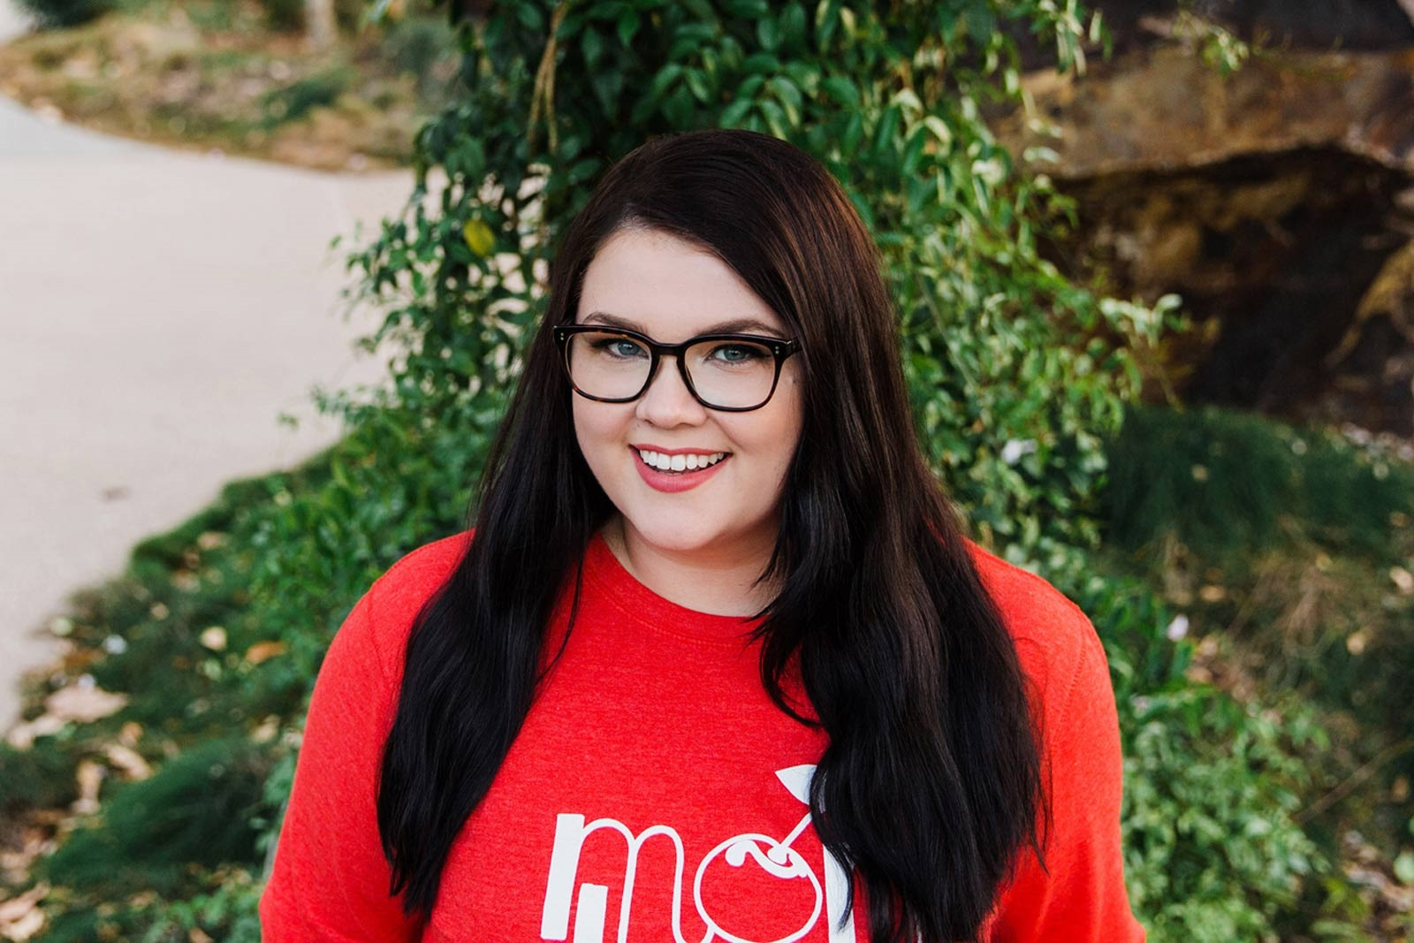

Jessica Townsend was born on 18th April 1985 in Queensland and still lives there although she has “dipped in and out “ of London life over the past decade, always gathering ideas for her books.

She was previously a copywriter and editor of a children’s wildlife magazine for Steve Irwin’s Australia Zoo.

Some of her fascinations include public transport, ancient cities, hotels, secret societies and gigantic cats. Many of these make it into her award winning book “Nevermoor: The Trials of Morrigan Crow”

**Website: www.guybass.com**

