**Polly Ho-Yen**

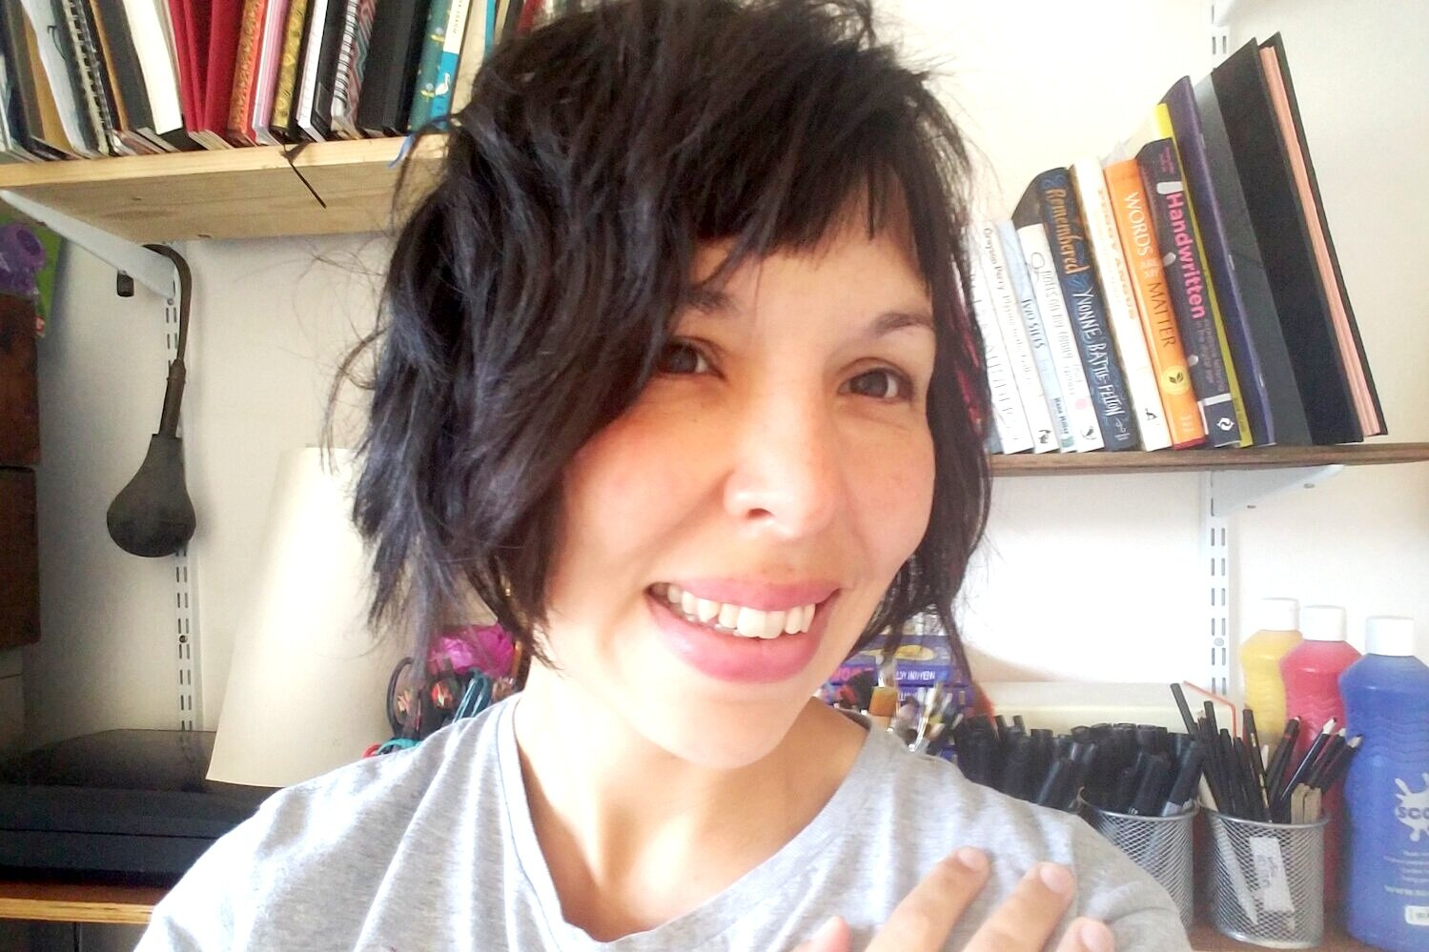

Polly Ho-Yen was born in Northampton and brought up in Buckinghamshire. She studied English at Birmingham University before working in publishing for several years.

Her first novel, “Boy in the Tower”, published in July 2014 by Random House Children's Publishers, was nominated for the Carnegie Medal, shortlisted for the Blue Peter Book Award and the Waterstones Children’s Book Prize. Her second novel “Where Monsters Lie” was published in 2016 and her third novel,***“***Fly Me Home”, was published in 2017. Both of these novels were also nominated for the Carnegie Medal.

She now writes full-time and lives in Bristol with her husband.