**Patricia MacLachlan**

Patricia MacLachlan is a children's writer who won the 1986 Newbery Medal for “Sarah, Plain and Tall”. Her other works in the Sarah, Plain and Tall series include “Skylark”, “Caleb's Story”, and “More Perfect than the Moon”.

She attended the University of Connecticut. In 1980, at the age of forty-two, she published her first novel, “Through Grandpa's Eyes”.

She was born in Cheyenne, Wyoming in the USA. In 1962, she married longtime partner, Robert MacLachlan. She has two sons, John and Jamie.

Her popular book, “Sarah, Plain and Tall”, was adapted into a 1991 TV movie starring actress Glenn Close.

She has always had a love for dogs and was named after her Mum’s favourite dog!

[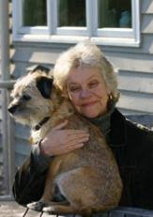](http://www.google.co.uk/url?sa=i&rct=j&q=&esrc=s&source=images&cd=&cad=rja&uact=8&ved=2ahUKEwjohOqgz6_lAhUxzYUKHQ8fBzwQjRx6BAgBEAQ&url=http://mesinnapkinkerosene2240mesinradioracksedep.mnyhmss.tk/patricia-maclachlan-books&psig=AOvVaw0D6-NJYkGoRpsBMglht461&ust=1571825062464516)