**Lissa Evans**

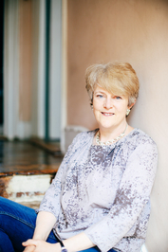

Lissa Evans is from the West Midlands and now lives in London with her family. She spent much of her childhood in her local library reading her way through the book collections there.

Lissa went on to work as a Junior Doctor but switched to working as a producer and director for the BBC on some very well-known programmes. Impressively, Lissa also won a BAFTA for her work on the comedy programme, *Father Ted*.

Lissa writes for adults and children. Her first book was published in 2002 and she continues to be a voracious reader.

If you’d like to find out more about Lissa Evans then go to <http://lissaevans.com>