**Julia Green**

[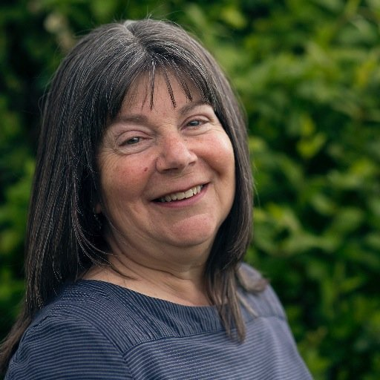](https://www.google.co.uk/url?sa=i&rct=j&q=&esrc=s&source=images&cd=&cad=rja&uact=8&ved=2ahUKEwj4noKptNrjAhUN3OAKHfpJCBwQjRx6BAgBEAU&url=https://twitter.com/jgreenauthor&psig=AOvVaw22me4Hhrxah3N_nZEl0Pu1&ust=1564499323281149)

Julia grew up in Ashtead, a small village in Surrey. As a child she loved reading and writing, playing with her sisters and friends, in the woods, the fields and in the stream. She went to St Giles Primary School in Ashtead, and Nonsuch High School for Girls in Cheam. Julia then studied English & American Literature at the University of Kent in Canterbury, and went on to do an M. Phil in English Studies. Later, she did a Creative Writing PhD at Bath Spa University. She is now Professor of Writing for Young People at Bath Spa University.   
She lives in Bath but loves to spend time exploring the islands of the Outer Hebrides and the Northumberland coast.