**James Bishop**

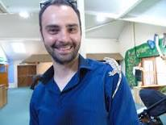

James was born in Oxfordshire and is proud of the fact that he only moved one town over from where he grew up to where he lives now.

He was the runner up in the 2016 ITV “Lorraine's Top Tales” competition. Inspired to write a comic-book style superhero book by his vast collection of comic books and by the birth of his new-born baby, James set to work writing about a boy with a rare superpower and Iguana Boy was born.