**Dave Shelton**

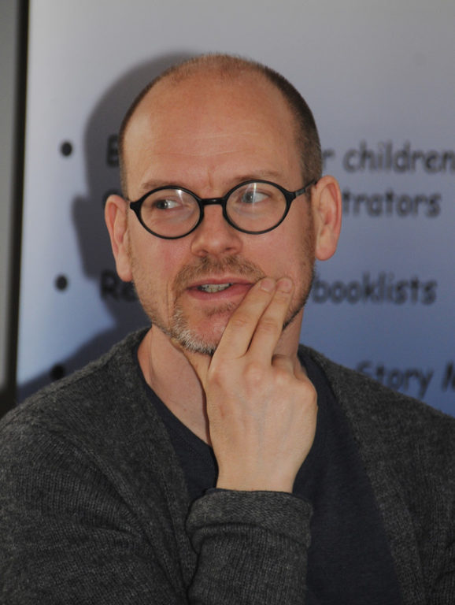

Dave was born and grew up in Leicester. Around the age of 12, a teacher told him on seeing the doodles in his notebook, that he could probably be an author and illustrator. It came true! He was educated at Loughborough, Cambridge and Brighton.

Dave now lives in Cambridge with his wife, step-daughter and a cat, whose name is too stupid to mention.

He likes comics, cricket and crosswords. His comic strip “Good Dog, Bad Dog” has appeared in the DFC comic, The Phoenix and The Guardian.