**Amber Lee Dodd**

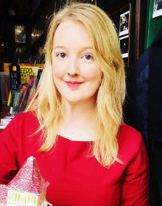

Amber Lee Dodd was born and grew up on the island city of Portsmouth. As a child she loved the waltzers, swimming in the sea and even lost wellies in the marshes. Now, when not writing, she likes looking for hats in charity and second-hand shops.

School life was difficult for Amber Lee, as she is dyslexic, and nobody recognised it. Eventually a teacher introduced story time to her class and Amber Lee’s life was changed forever as that teacher recognised a storyteller in the making.