**Philip Reeve**

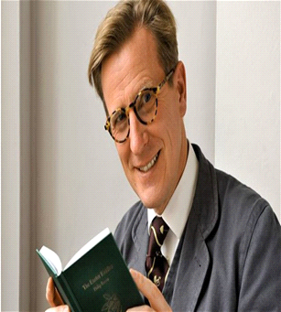

Philip was born in 1966, in Brighton, England. He wrote his first book at the tender age of 5, about a spaceman called Spike and his trusty space dog, Spook.

He’s been a writer, a producer and director as well as writing amazing books for children and young adults. His well-known books include “Goblins”, “Oliver and the Seawigs” and Railhead. Arguably, his most famous series is “Mortal Engines”, which was made into a film in 2018.

Philip is also a talented artist and has illustrated many Horrible Histories and Murderous Maths books. Philip now lives in Dartmoor in Devon, with his wife and son.

If you’d like to find out more about Philip Reeve and his books you can visit <http://www.philip-reeve.com/>