**Chris Hoy and Joanna Nadin**

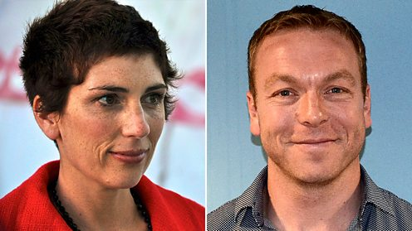

Chris Hoy was born on 23rd March 1976 and is Great Britain’s joint most successful athlete of all time. Whilst watching “ET” as a child, he saw a BMX bike for the first time. His own bike was from a jumble sale but his dad did it all up for him and Chris loved it. From then on, he got into cycling.

Joanna Nadin was born in Northampton. She studied drama but moved on then to do an MA in Political Communications. She has worked as a journalist but also in politics. Joanna has written over 70 books.