**Susan Gates**

[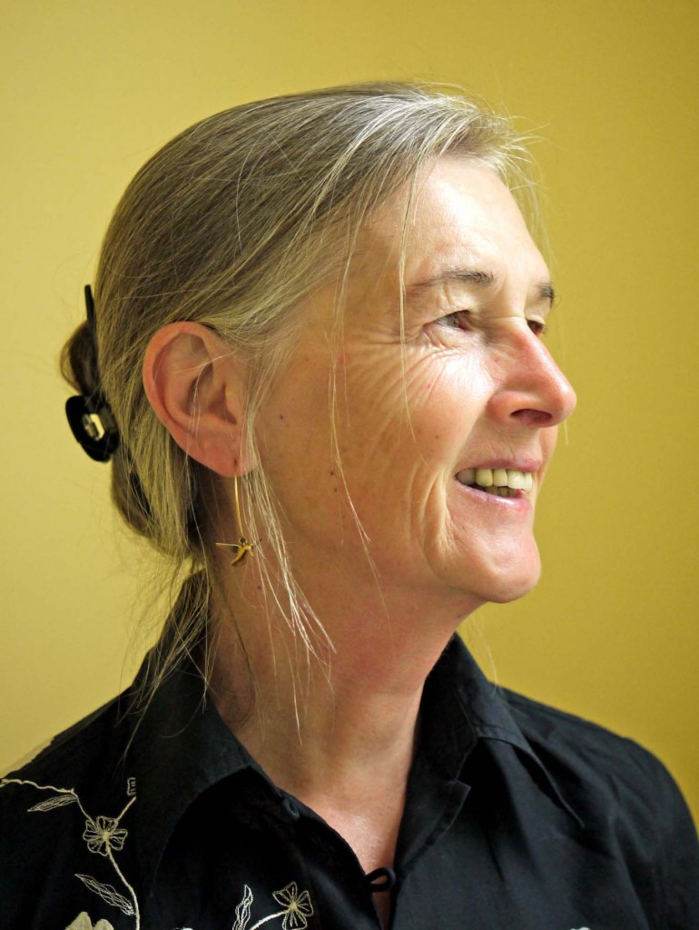](http://www.google.co.uk/url?sa=i&rct=j&q=&esrc=s&source=images&cd=&cad=rja&uact=8&ved=2ahUKEwjfk7yYjNDiAhVNhxoKHTpPBmUQjRx6BAgBEAU&url=/url?sa%3Di%26rct%3Dj%26q%3D%26esrc%3Ds%26source%3Dimages%26cd%3D%26ved%3D2ahUKEwi-5eWBjNDiAhVPxYUKHdcgDfAQjRx6BAgBEAU%26url%3Dhttps://www.davidhigham.co.uk/authors-dh/susan-gates/%26psig%3DAOvVaw1DThXrLyTDClOoj384_Rna%26ust%3D1559746847405022&psig=AOvVaw1DThXrLyTDClOoj384_Rna&ust=1559746847405022)

Susan Gates was born in Grimsby in 1950. Growing up she read a lot of science fiction and American literature, which she went on to study at Warwick University. When she was 18, she became a teacher in Malawi and went to University on her return to England and afterwards continued to teach.

Susan never thought about becoming a writer when she was growing up. "Writing seemed to be a different world that kids like me could never be part of—but I was wrong." she said in an interview.

Susan’s books have been shortlisted for many prizes over the years, including the Carnegie Medal.