**Andy Griffiths**

[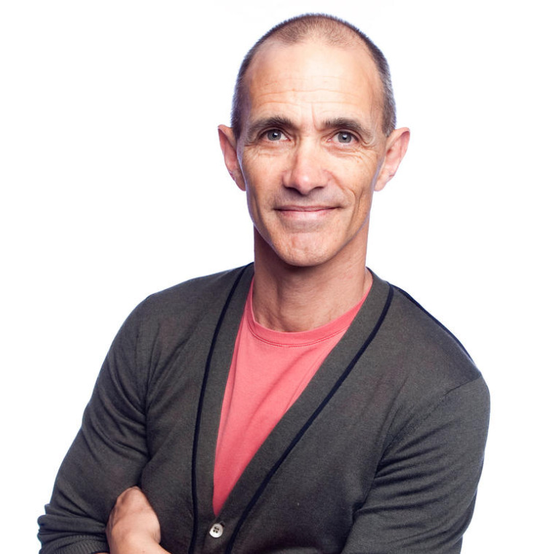](http://www.google.co.uk/url?sa=i&rct=j&q=&esrc=s&source=images&cd=&ved=2ahUKEwiY5obQqoTjAhVETBoKHQErBPEQjRx6BAgBEAU&url=http://www.halogen.org.au/speaker.php?speakerid%3D135&psig=AOvVaw0U7jP_syDtBOFxnKWPl5uN&ust=1561541784340612)

Andrew Noel "Andy" Griffiths is an Australian children's book author and comedy writer. He was born on 3rd September 1961 in Melbourne. He is known for “Just!” which was adapted into an animated television series called “What's with Andy?” Previously he has worked as a high-school teacher, been the lead singer in a rock band and a stand-up comedian. He is a passionate advocate for literacy, has two daughters and lives in Melbourne, Australia. He is one of Australia’s bestselling children’s authors and works closely with Terry Denton.

[](https://www.amazon.co.uk/Tom-McLaughlin/e/B008VGJPO2?ref=dbs_a_def_rwt_sims_vu00_r3_c0)

[Tom McLaughlin](https://www.amazon.co.uk/Tom-McLaughlin/e/B008VGJPO2?ref=dbs_a_def_rwt_sims_vu00_r3_c0)

[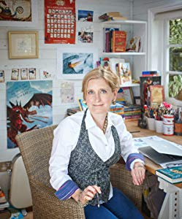](https://www.amazon.co.uk/Cressida-Cowell/e/B000APSVVK?ref=dbs_a_def_rwt_sims_vu00_r3_c1)

[Cressida Cowell](https://www.amazon.co.uk/Cressida-Cowell/e/B000APSVVK?ref=dbs_a_def_rwt_sims_vu00_r3_c1)

[](https://www.amazon.co.uk/Pamela-Butchart/e/B00K6LNU8C?ref=dbs_a_def_rwt_sims_vu00_r4_c0)

[Pamela Butchart](https://www.amazon.co.uk/Pamela-Butchart/e/B00K6LNU8C?ref=dbs_a_def_rwt_sims_vu00_r4_c0)

[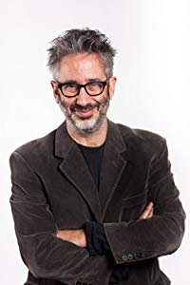](https://www.amazon.co.uk/David-Baddiel/e/B00JLAW18Y?ref=dbs_a_def_rwt_sims_vu00_r4_c1)

[David Baddiel](https://www.amazon.co.uk/David-Baddiel/e/B00JLAW18Y?ref=dbs_a_def_rwt_sims_vu00_r4_c1)

[](https://www.amazon.co.uk/George-Beard/e/B001IZ2JPA?ref=dbs_a_def_rwt_sims_vu00_r5_c0)

[George Beard](https://www.amazon.co.uk/George-Beard/e/B001IZ2JPA?ref=dbs_a_def_rwt_sims_vu00_r5_c0)

[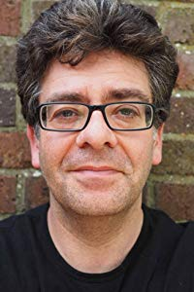](https://www.amazon.co.uk/David-Solomons/e/B00QSWU44Q?ref=dbs_a_def_rwt_sims_vu00_r5_c1)

[David Solomons](https://www.amazon.co.uk/David-Solomons/e/B00QSWU44Q?ref=dbs_a_def_rwt_sims_vu00_r5_c1)

**Are you an author?**

Help us improve our Author Pages by updating your bibliography and submitting a new or current image and biography.

[Learn more at Author Central](https://authorcentral.amazon.co.uk/)



1 211 21

[*Previous page*](https://www.amazon.co.uk/Andy-Griffiths/e/B001H6MN4M)

1. [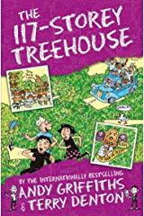](https://www.amazon.co.uk/gp/product/1509885277/ref=dbs_a_def_rwt_bibl_vppi_i0)

Paperback

£5.24

1. [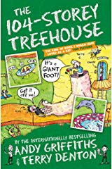](https://www.amazon.co.uk/gp/product/1509833773/ref=dbs_a_def_rwt_bibl_vppi_i1)

Paperback

£4.89

1. [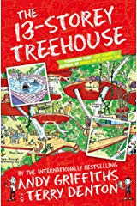](https://www.amazon.co.uk/gp/product/1447279786/ref=dbs_a_def_rwt_bibl_vppi_i2)

Paperback

£3.78

1. [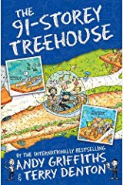](https://www.amazon.co.uk/gp/product/150983916X/ref=dbs_a_def_rwt_bibl_vppi_i3)

Paperback

£5.37

1. [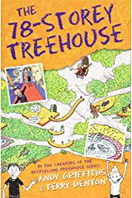](https://www.amazon.co.uk/gp/product/1509833757/ref=dbs_a_def_rwt_bibl_vppi_i4)

Paperback

£6.99

[*Next page*](https://www.amazon.co.uk/Andy-Griffiths/e/B001H6MN4M)

**Author Updates**



[*Previous page*](https://www.amazon.co.uk/Andy-Griffiths/e/B001H6MN4M)

he was a vocalist with alternative rock bands Gothic Farmyard and Ivory Coast. In 1992 he turned to writing.