**Frank Cottrell Boyce**

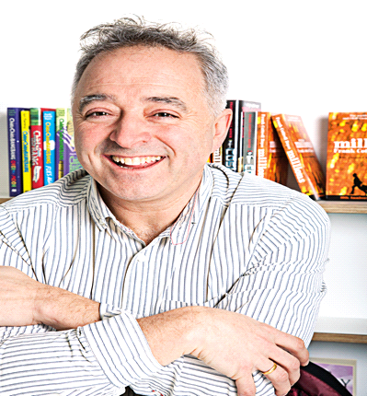

Frank Cottrell Boyce was born and raised in Liverpool.

He studied at Oxford University.

Frank has written several children’s books including Millions, which won the Carnegie Medal, and the sequel to Chitty Chitty Bang Bang.

He is also a screenwriter and has written for Coronation Street.

One of Frank’s most recent achievements was to write the opening ceremony for the London Olympics.