**Ciaran Murtagh**

[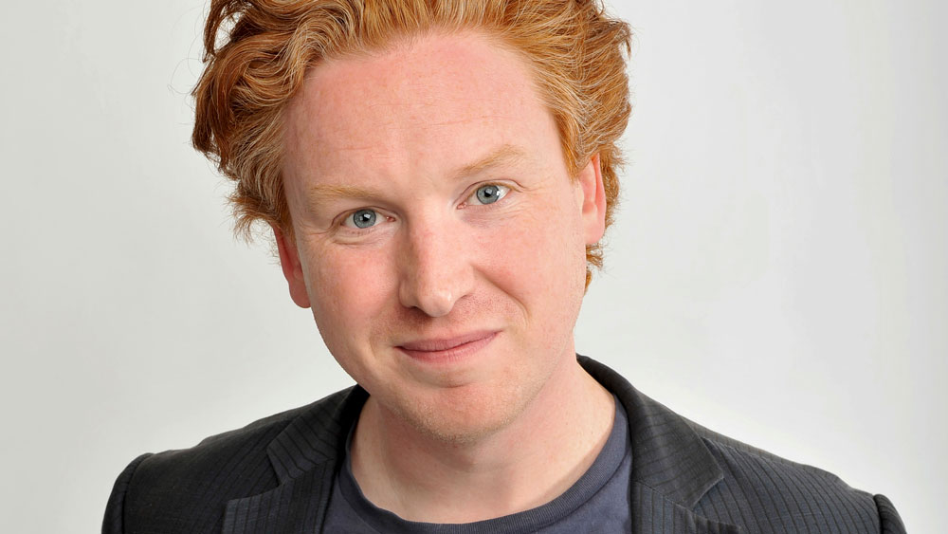](http://www.google.co.uk/url?sa=i&rct=j&q=&esrc=s&source=images&cd=&ved=2ahUKEwi58tLUk4TgAhUFBGMBHb5yDzUQjRx6BAgBEAU&url=http://evewhite.co.uk/authors/ciaran-murtagh/&psig=AOvVaw3-wkK_T0rivofzLxWCfEZO&ust=1548341484809815)

Ciaran Murtagh, born in 1978, lives and works in London. He is the author of over 35 children’s books and is also a BAFTA award winning scriptwriter, having been involved with Shaun the Sheep, Mr Bean and Dennis and Gnasher to name a few.

Ciaran tours the world and has visited countries such as China and Oman, leading workshops as well as appearing at book festivals all over Britain.