**R. J. Anderson**

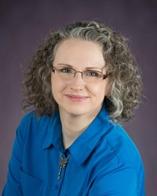

Born in Uganda and raised in various parts of Ontario, Canada where she now lives, Rebecca has spent much of her life dreaming of other worlds entirely.

As a child, she immersed herself in fairy tales, mythology, and the works of [C.S. Lewis](http://cslewis.drzeus.net/), [J.R.R. Tolkien](http://www.tolkiensociety.org/tolkien/biography.html) and [E. Nesbit](http://www.isfdb.org/cgi-bin/ea.cgi?E._Nesbit); later she found inspiration in books by [Ursula LeGuin](http://www.ursulakleguin.com/), [Patricia A. McKillip](http://www.goodreads.com/author/show/25.Patricia_A_McKillip) and [Robin McKinley](http://www.robinmckinley.com/), and learned to take as much pleasure from the authors’ lyrical style as the stories they told.

Now married and a mother of three, Rebecca reads to her sons the classic works of fantasy and science fiction that enlivened her own childhood, and tries to bring a similar excitement and timeless wonder to the novels she writes for children and teens.