**Michael Morpurgo**

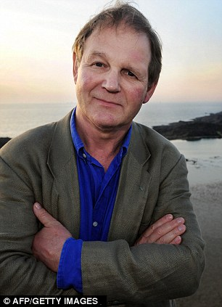

Michael has written over 100 books. His 100th book was “Private Peaceful”.

He once was described as being “rather stupid but good at rugby”. He has worked as a primary teacher.

He writes from 9.30am-12.30pm - in bed! Michael drew his inspiration for “Private Peaceful” from interviews he conducted with World War 1 Veterans.

He was the third Children’s Laureate from 2003-2005