**Katherine Rundell**

[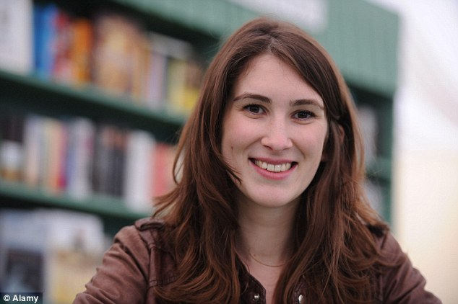](https://maximumpop.co.uk/wp-content/uploads/2016/03/Katherine-Rundell.jpg)

Katherine Rundell was born in 1987 and grew up in Africa and Europe, both of which have inspired some of her books.

In 2008, she was elected a Fellow of All Souls College, Oxford and has been known to climb on to the roof there.

She doesn’t remember ever not wanting to be a writer but hadn’t thought about writing for children. She writes early in the morning and late at night.

Katherine won the Waterstones Children’s prize for Rooftoppers in 2014.