**E. B. White**

[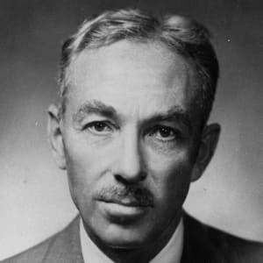](https://www.google.co.uk/url?sa=i&rct=j&q=&esrc=s&source=images&cd=&cad=rja&uact=8&ved=2ahUKEwian6LW4eLeAhUJIcAKHRKoCs0QjRx6BAgBEAU&url=https://www.biography.com/people/eb-white-9529308&psig=AOvVaw0mb1Z5lYJVdKxqeDvgLMPf&ust=1542796121915316)

E. B. (Elwyn Brooks) White was born on 11th July 1899 in Mount Vernon. He graduated from Cornell University in 1921 and worked as a reporter for various publications before joining the staff at “The New Yorker”.

He wrote both children’s and adult books and was elected to the American Academy of Arts and Letters in 1973. He won many awards for his writing, including the Laura Ingalls Wilder Medal for a substantial and lasting contribution to literature for children.

He died on 1st October 1985.