**Chris Bradford**

[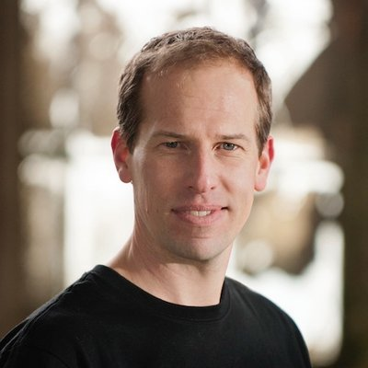](https://www.google.co.uk/url?sa=i&rct=j&q=&esrc=s&source=imgres&cd=&ved=2ahUKEwiC6_XlruPeAhUJCcAKHZotBvoQjRx6BAgBEAU&url=https://twitter.com/youngsamurai&psig=AOvVaw3Drf2FRjC9RAenalhtIa4I&ust=1542816851713643)

"I write the type of books I'd want to read - books filled with relentless action, believable characters and a plot that twists and turns through the pages!”

For his Young Samurai series, Chris Bradford trained in various martial arts including karate, ninjutsu and earned his black belt in Zen Kyu Shin Taijutsu.

Before becoming a full-time author, he was a professional musician, who once performed for Queen Elizabeth II, a songwriter and music teacher.

He lives on the South Downs, England with his two sons.