**Alan Dapre**

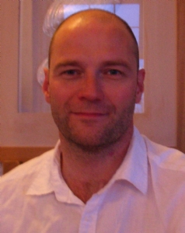

Alan Dapre grew up in Kent. After school he studied Creative Arts in Nottingham. He has worked as a teacher, BBC Radio playwright and children’s

TV scriptwriter. In his mid-thirties, he gave up teaching to write full-time.

He now lives in Ayrshire and works from home in an office overlooking a castle.