**Dermot O’Leary**

[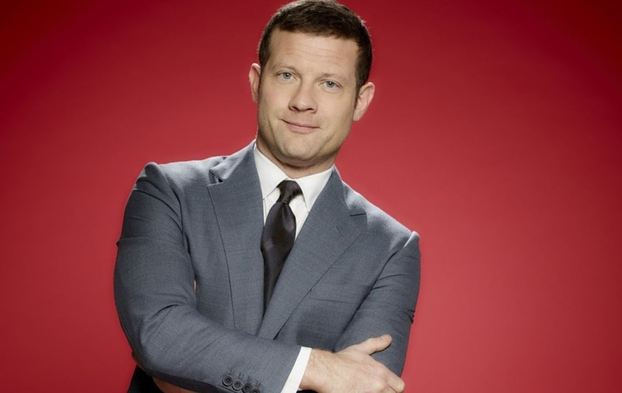](https://www.google.co.uk/url?sa=i&rct=j&q=&esrc=s&source=images&cd=&cad=rja&uact=8&ved=2ahUKEwinka2y76XcAhXHVZQKHdZ0A0UQjRx6BAgBEAU&url=https://www.irishnews.com/magazine/entertainment/2017/03/23/news/dermot-o-leary-dedicates-the-nightly-show-to-londoners-976414/&psig=AOvVaw3cj1ky-13j0C__2XmehlFl&ust=1531907767383937)

Dermot O’Leary was born in Colchester on 24th May 1973 to Irish parents. At school he didn’t work as hard as he could have and didn’t pass many GSCEs. He went on to Colchester Sixth Form College where he resat his exams and then moved on to Middlesex University, where he did a degree in media studies with politics.

Dermot started out as a DJ for Essex Radio before moving to television. His first presenting job was on T4 for Channel 4. He is probably best known for presenting The X Factor.