**Lisa Thompson**

Lisa Thompson was born in Essex on 5th May 1973. Her debut novel, The Goldfish Boy, was published in the UK in January 2017, where it was a Waterstones Children’s Book of the Month and went on to become a bestseller. “The Goldfish Boy” has been nominated for various awards including the Carnegie Medal, The Branford Boase Award and the Waterstones Children’s Book Prize. It has been sold to nine territories around the world.

Before becoming a novelist, Lisa worked as a broadcast assistant for BBC Radio 2 and CPL Productions, where she got to make tea for lots of famous people.

She lives in Suffolk with her family.

[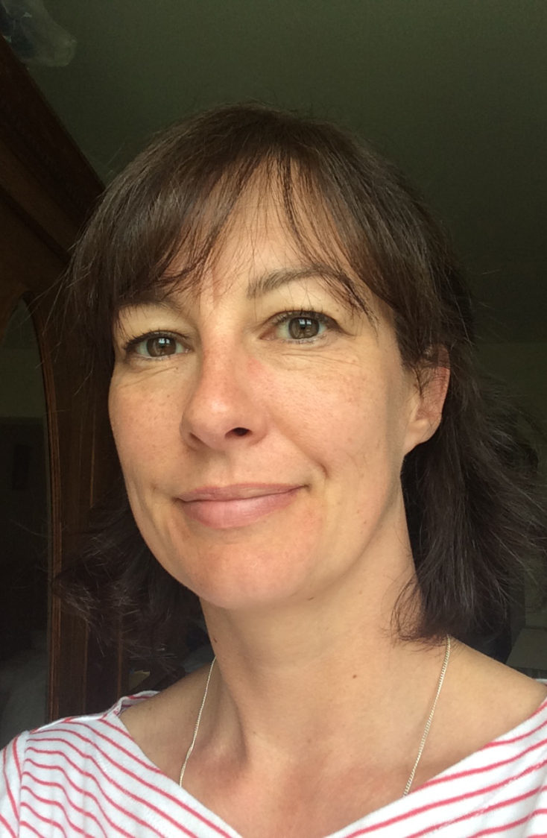](https://www.google.co.uk/url?sa=i&rct=j&q=&esrc=s&source=images&cd=&ved=2ahUKEwiBj6jx5ajdAhVBWBoKHT2QB1kQjRx6BAgBEAU&url=https://www.awesomebookawards.com/author/lisa-thompson/&psig=AOvVaw1v30g3ejwVFNXtomB_daGo&ust=1536406360918027)